CLOUDFRONT & ROUT 53

1. Configure VPC peering in cross regions.

**Launch instance in Ireland**

1. In the AWS console, region is set to rout EU-WEST-1
2. Go to **EC2 → Launch instance**.
3. Under **Name and tags**, set:
   * **Name** = Rout-53-peering

**B. Launch instance**

1. Change region in the top-right to **us-north-1**
2. Go to **EC2 → Launch instance** again(north Virginia)
3. Under **Name and tags**, set:
   * **Name** = ROUT-53

**C. Create cross-region VPC peering Ireland**

1. Switch back to **Europe (lreland)** region.
2. Go to **VPC → Peering connections**.
3. Click **Create peering connection**.
4. Fill **Peering connection settings**:
   * **Name** = Rout-53-peering
5. In **Select a local VPC to peer with**:
   * **VPC ID (Requester)** = vpc-0a72f92a36499c2e6

This VPC has CIDR 172.168.0.0/24.

1. In **Select another VPC to peer with**:
   * **Account** = *My account*
   * **Region** = **Another Region** → choose **us-north-1**
   * **VPC ID (Accepter)** = vpc-0a72f92a36499c2e6 (the default VPC in ireland).
2. Click **Create peering connection**.
   * A new peering pcx-0bd1174c6dce6e94e is created with status **Pending acceptance**.

**D. Accept the peering request in ireland eu-west-1**

1. Switch region (top-right) to **us-north-1**
2. Go to **VPC → Your VPCs** and confirm you have VPC:
   * vpc-09e3bb888e0a8e376 with CIDR 172.31.0.0/16.
3. In the left menu, click **Peering connections**.
4. You see the peering connection from ireland with status **Pending acceptance**.
5. Select that peering connection row.
6. Click **Actions → Accept request**.
7. A confirmation popup **“Accept VPC peering connection request”** shows:
   * **Requester VPC** = vpc-068d558547ab00f25, Region = us-north-1, CIDR 172.168.0.0/24
   * **Accepter VPC** = vpc-091907ad95e1cc0cce, Region = Ireland,eu-east-1, CIDR 172.31.0.0/16
8. Click **Accept request**.
9. The peering connection status changes to **Active**.

* **Update route tables** in both VPCs:
  + In **us-north-1 VPC (172.168.0.0/16)**: add a route to 172.31.0.0/24 with target = the **peering connection**.
  + In **us-west-1 VPC (172.31.0.0/24)**: add a route to 172.168.0.0/16with target = the **same peering connection**.

**Check CIDR Block of ireland VPC**

Region: **us-west-1**

1. Go to **VPC → Your VPCs**
2. Verify CIDR: 172.168.0.0/24

**Edit Route Table in Ireland (Accepter VPC)**

Region: **us-north-1**  
 VPC: vpc-09e3bb888e0a8e376 → CIDR: 172.31.0.0/16

1. Go to **VPC → Route tables**
2. Select **Main route table**
3. Click **Routes → Edit routes**
4. Add new route:
   * **Destination**: 172.168.0.0/24

**Target**: Select **Peering Connection** (pcx-0bd1174c6dce6e94e)

1. Click **Save changes**

This allows return traffic from Hyderabad to Stockholm.

**Check Private IP of ireland EC2 instance**

Region: ireland

1. EC2 Dashboard → Instances
2. Select instance ROUT-53-peering
3. Note the **Private IP**:
   * 172.31.26.203

**Test Connectivity from eu-west-1 EC2 → ireland**

Connected via SSH to **Ireland eu-west-1 EC2** (172.168.0.6)  
 Run ping command

Create one VPC IN us-north-1

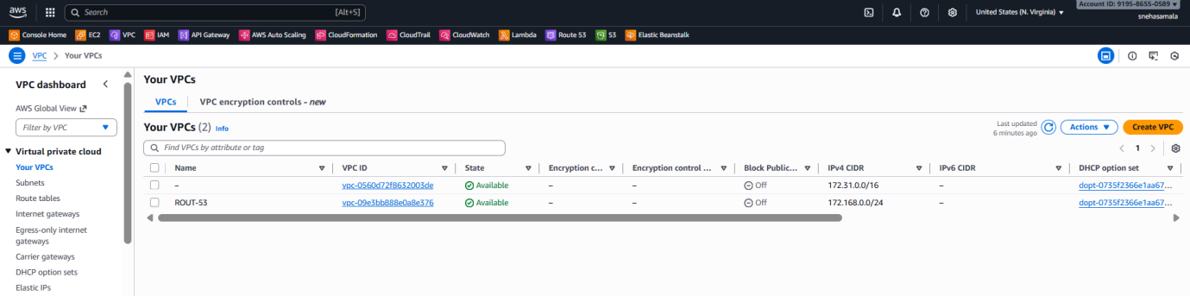

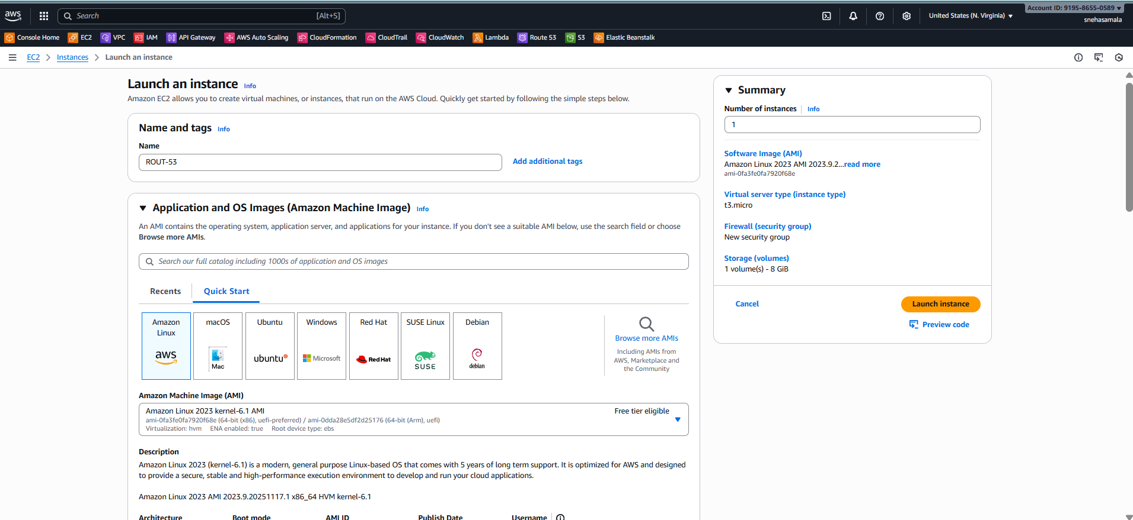

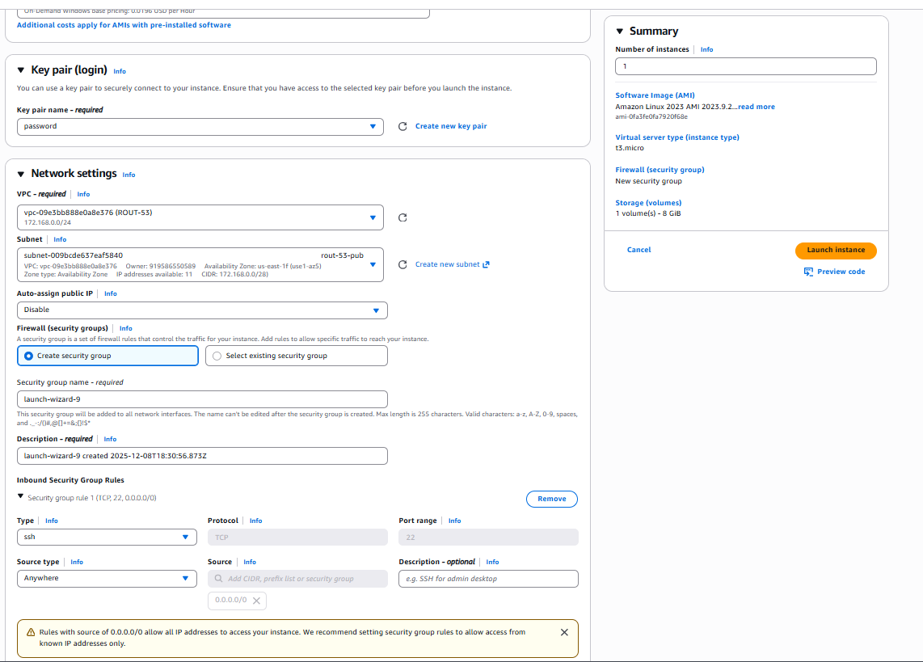

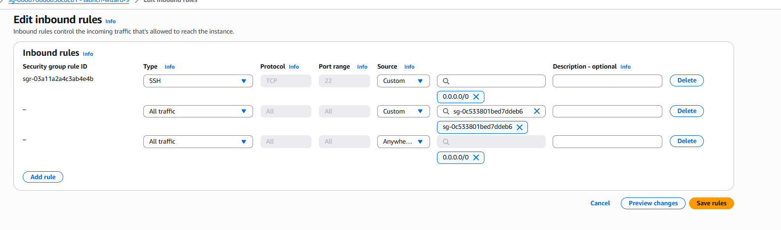

Another region

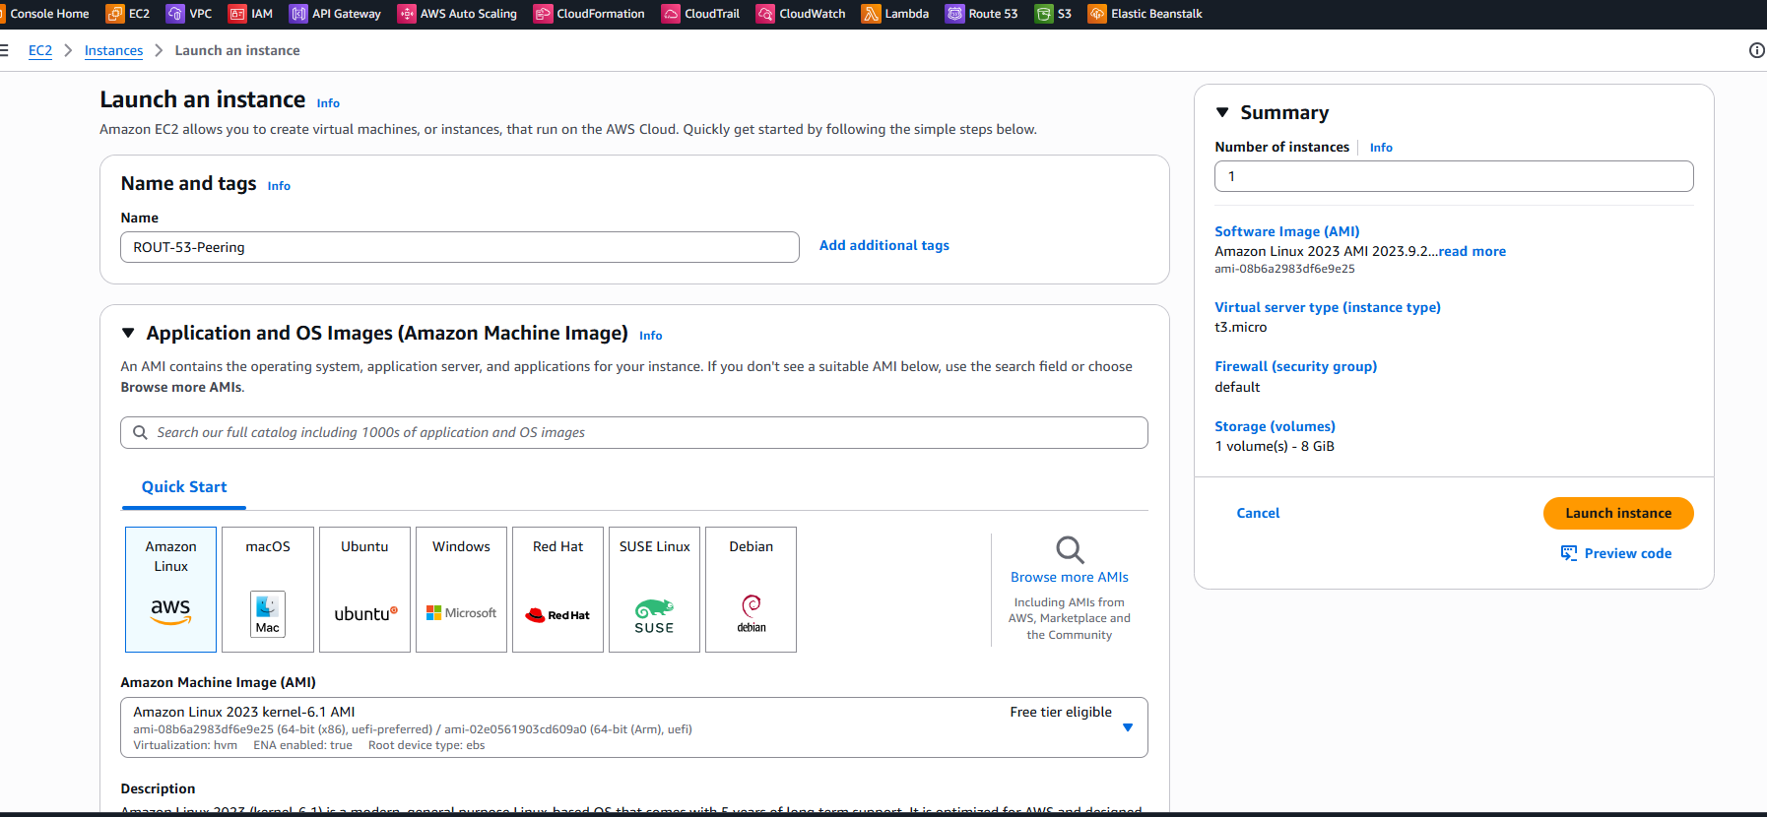

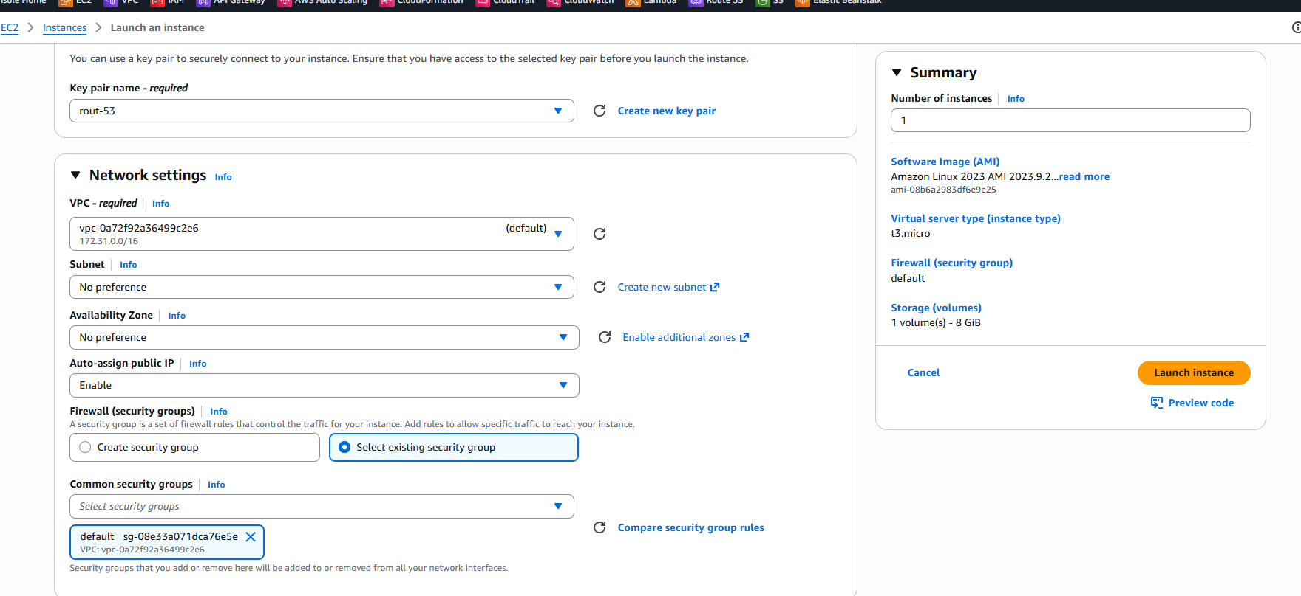

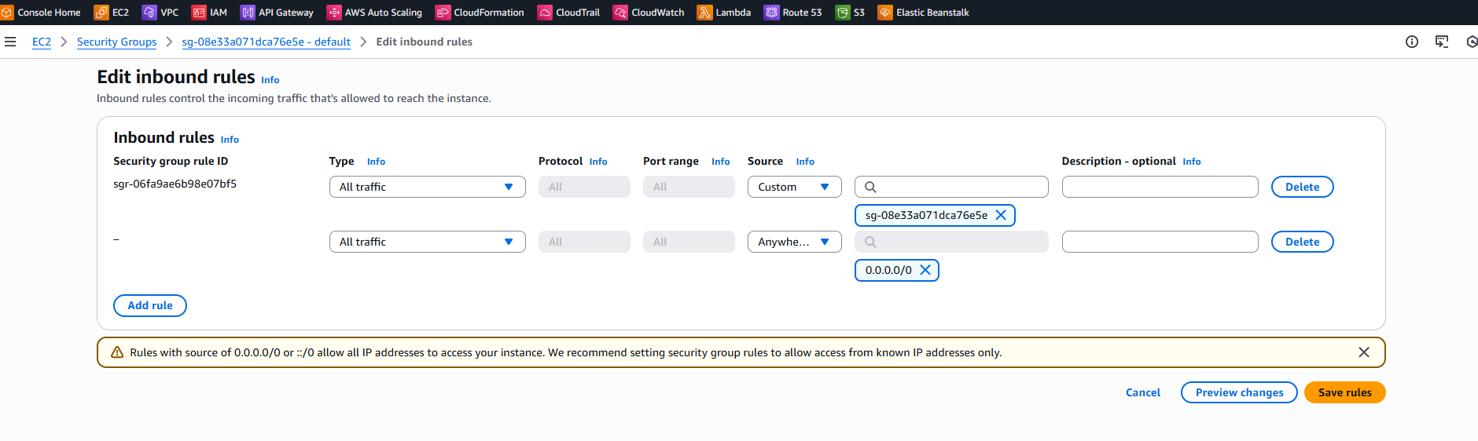

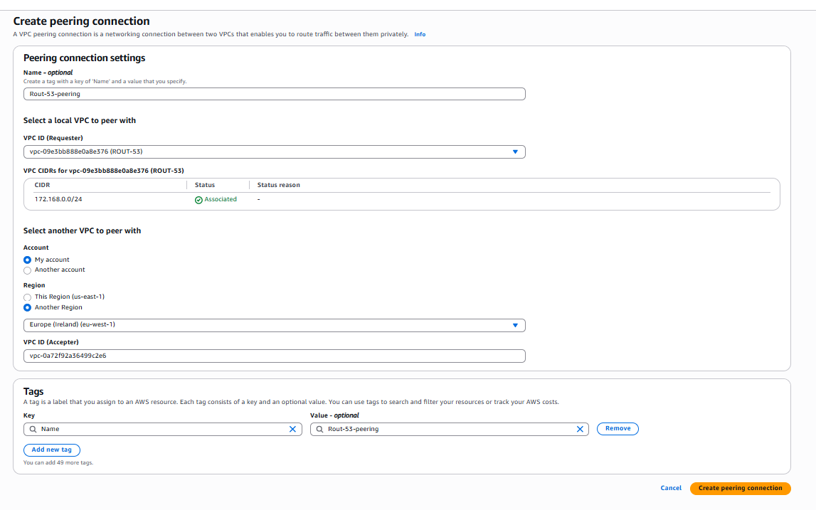

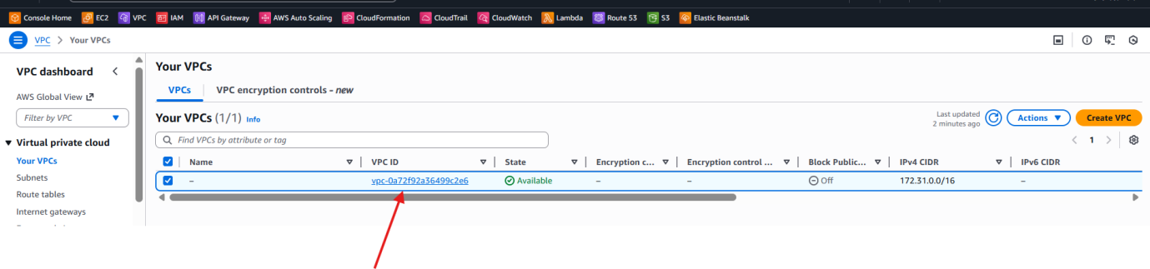

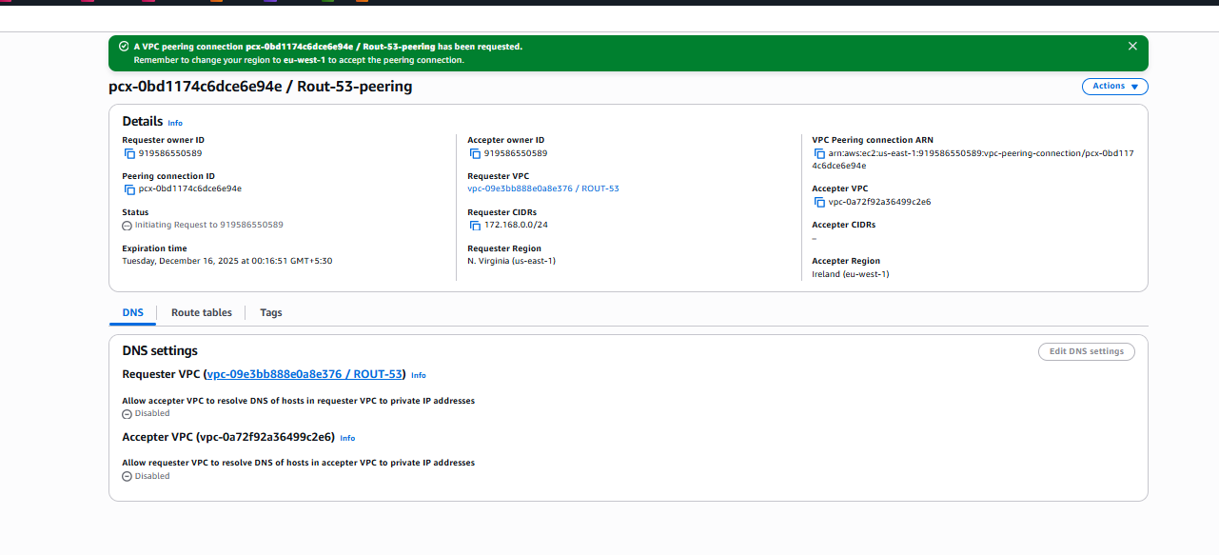

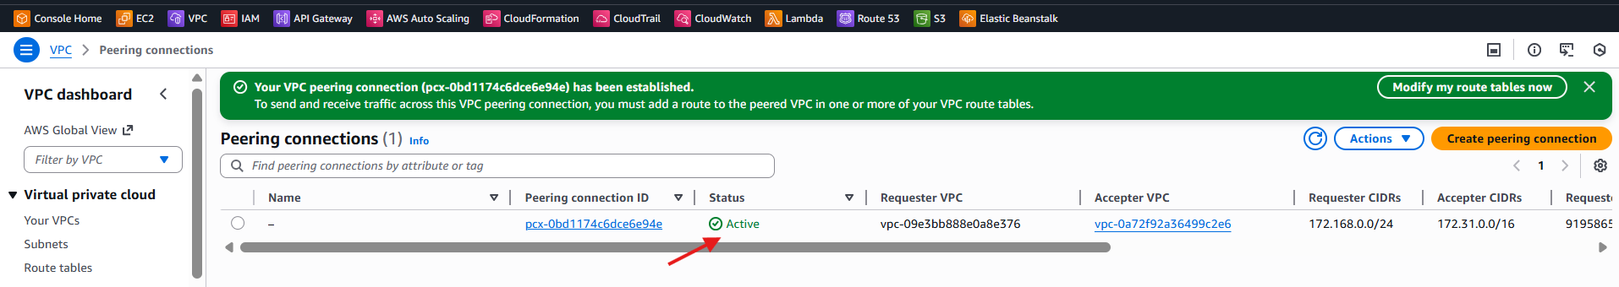

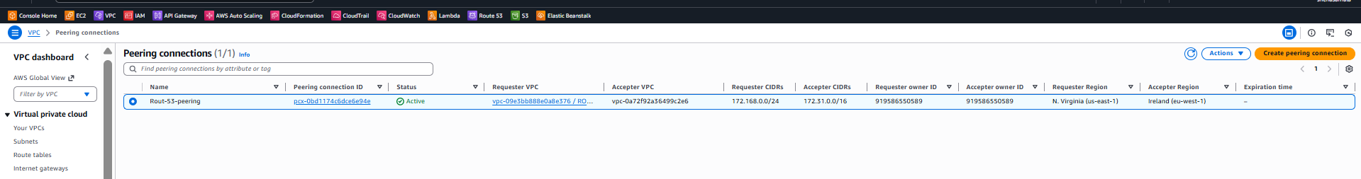

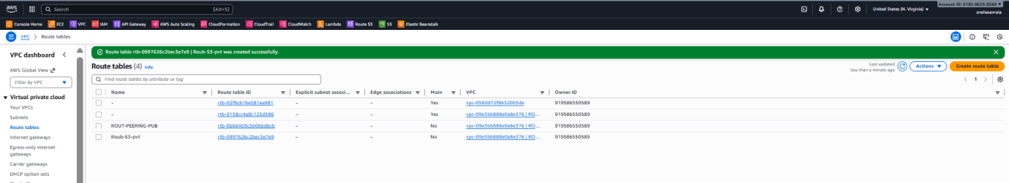

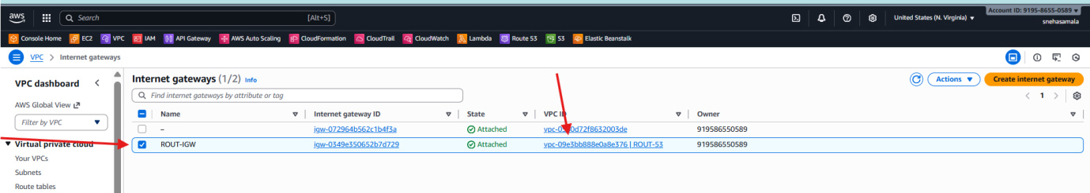

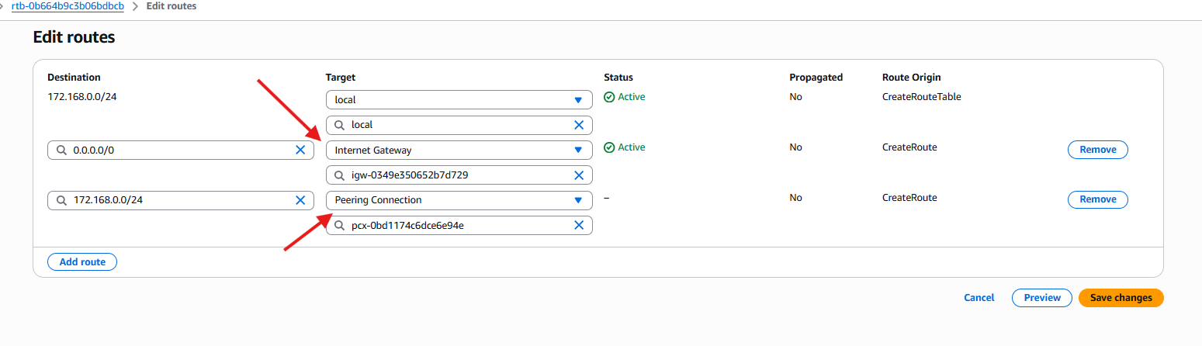

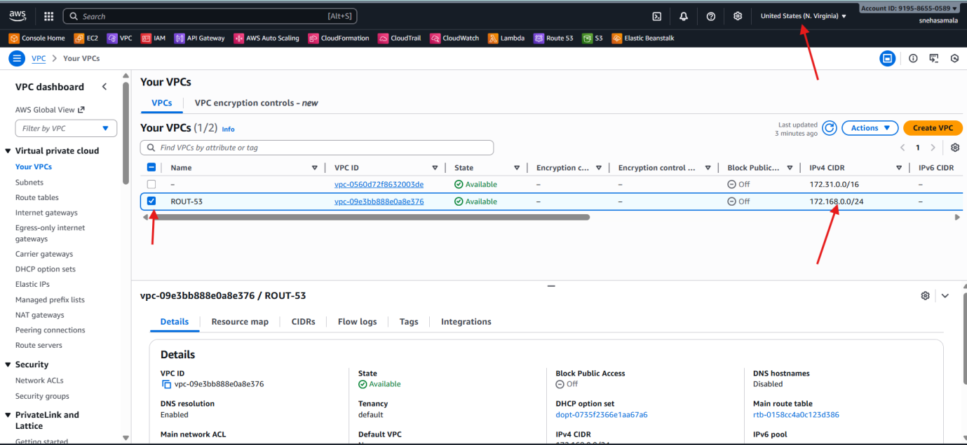

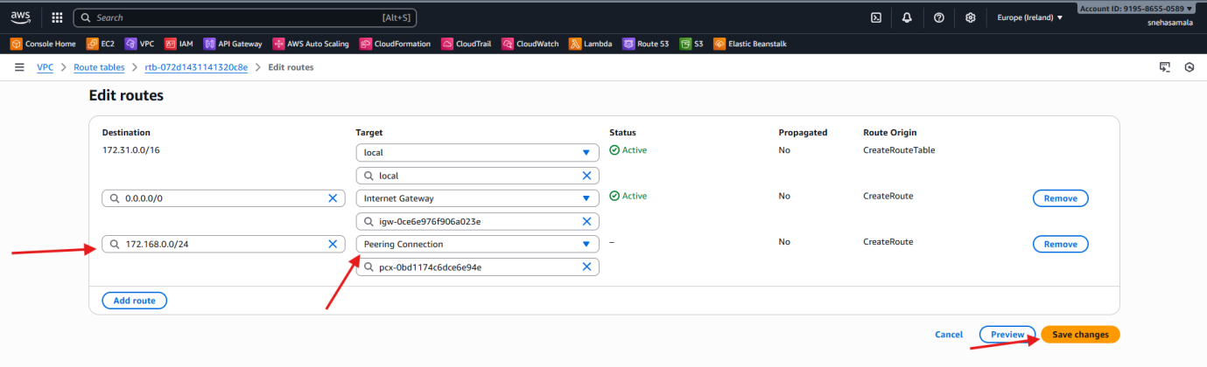

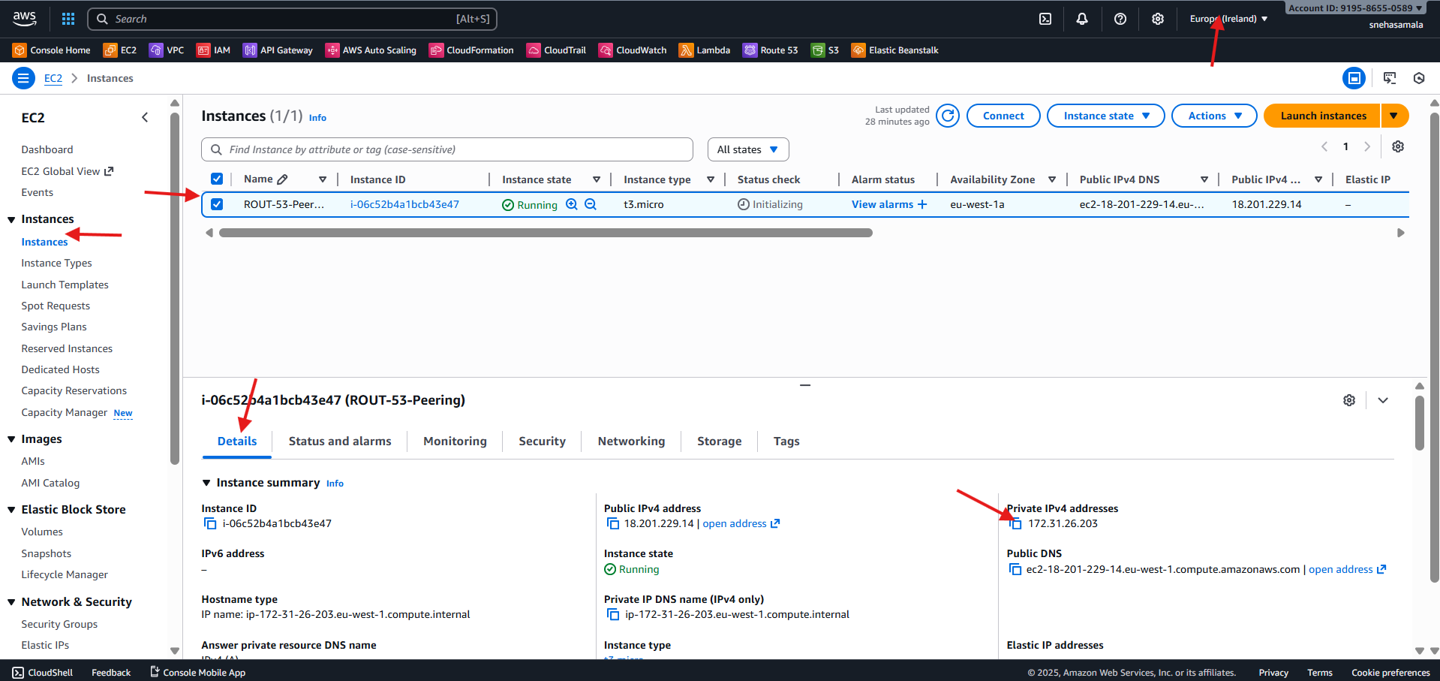

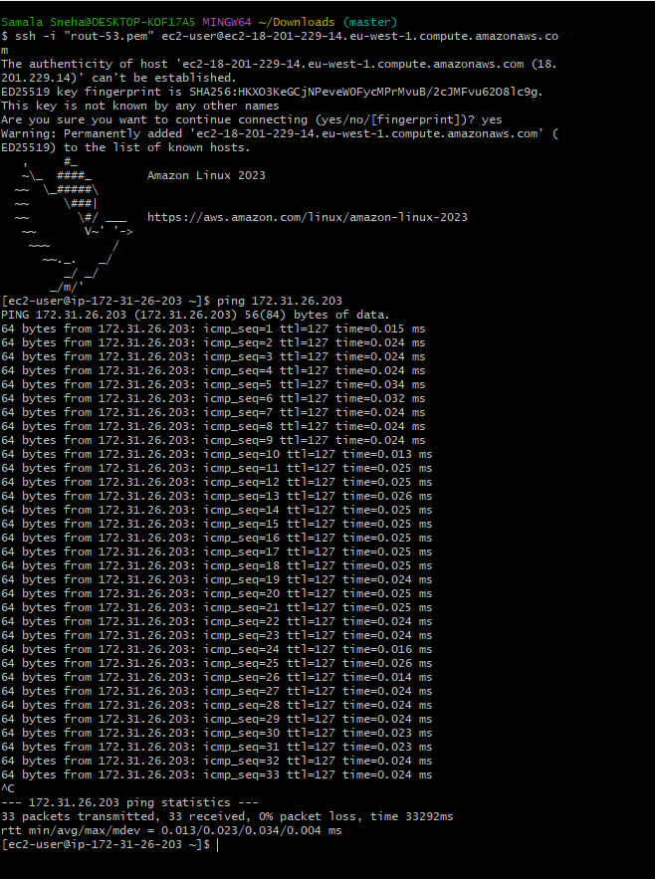

1. Purchase one domain from GoDaddy.

· Go to **GoDaddy.com**.

· Search for the domain name you want.

· Select an available domain from results.

· Click **Add to Cart**.

· Choose term (1 year, 2 years, etc.).

· Disable extra add-ons (privacy, email, hosting) if not needed.

· Click **Create Account / Sign In**.

· Enter payment details and complete the purchase.

· Go to **GoDaddy → My Products** to confirm the domain is active.

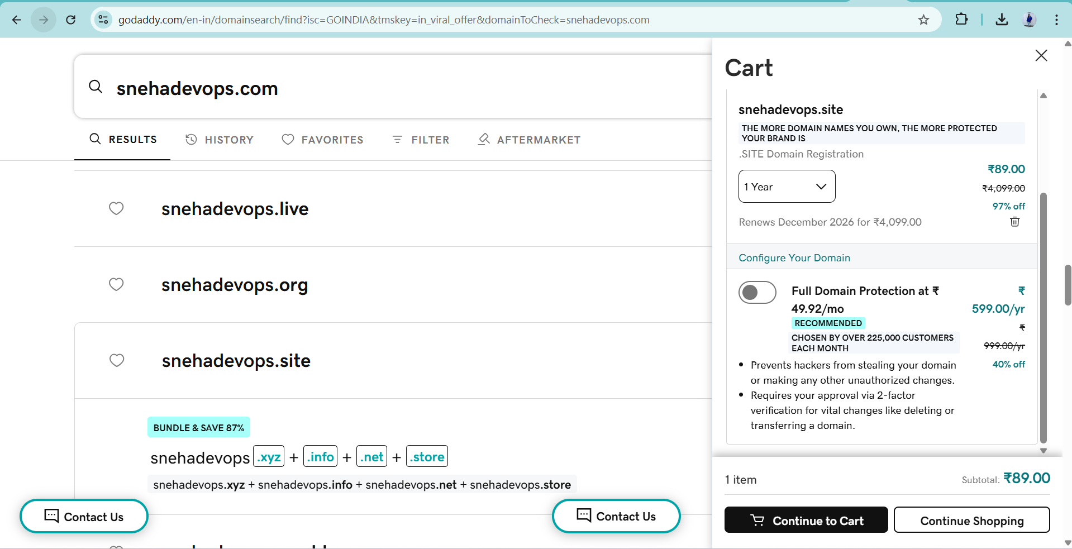

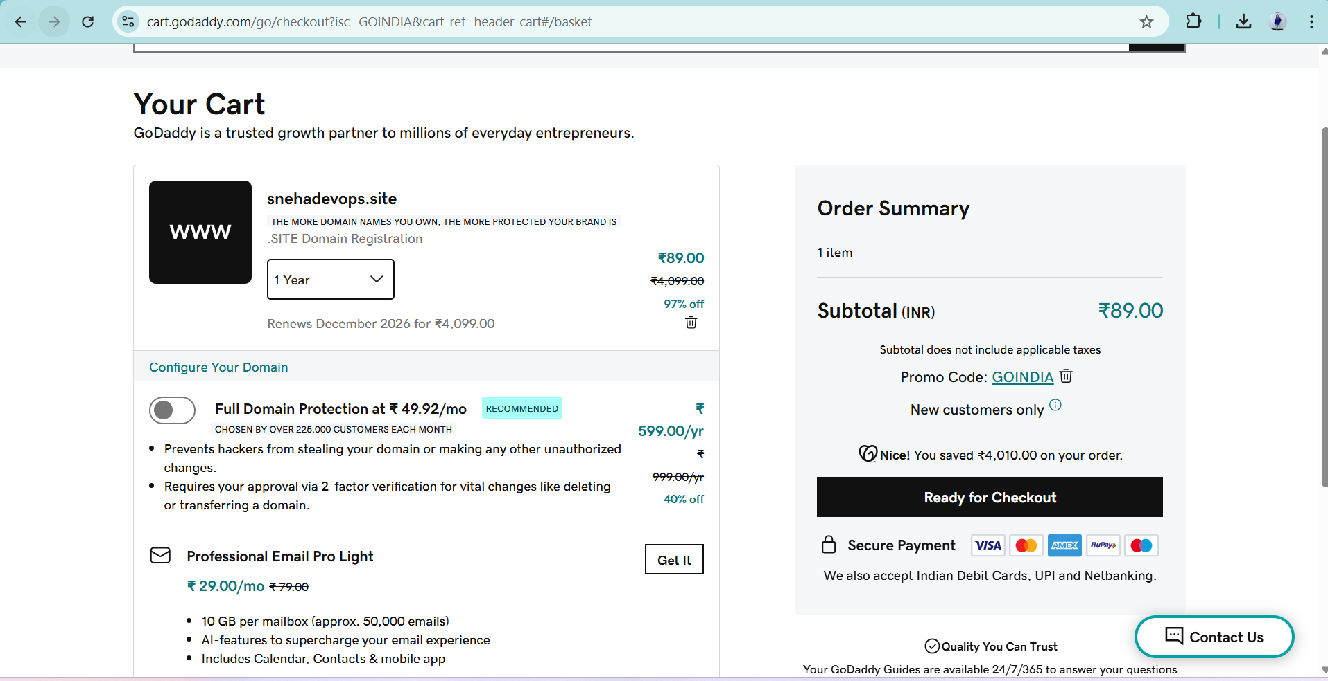

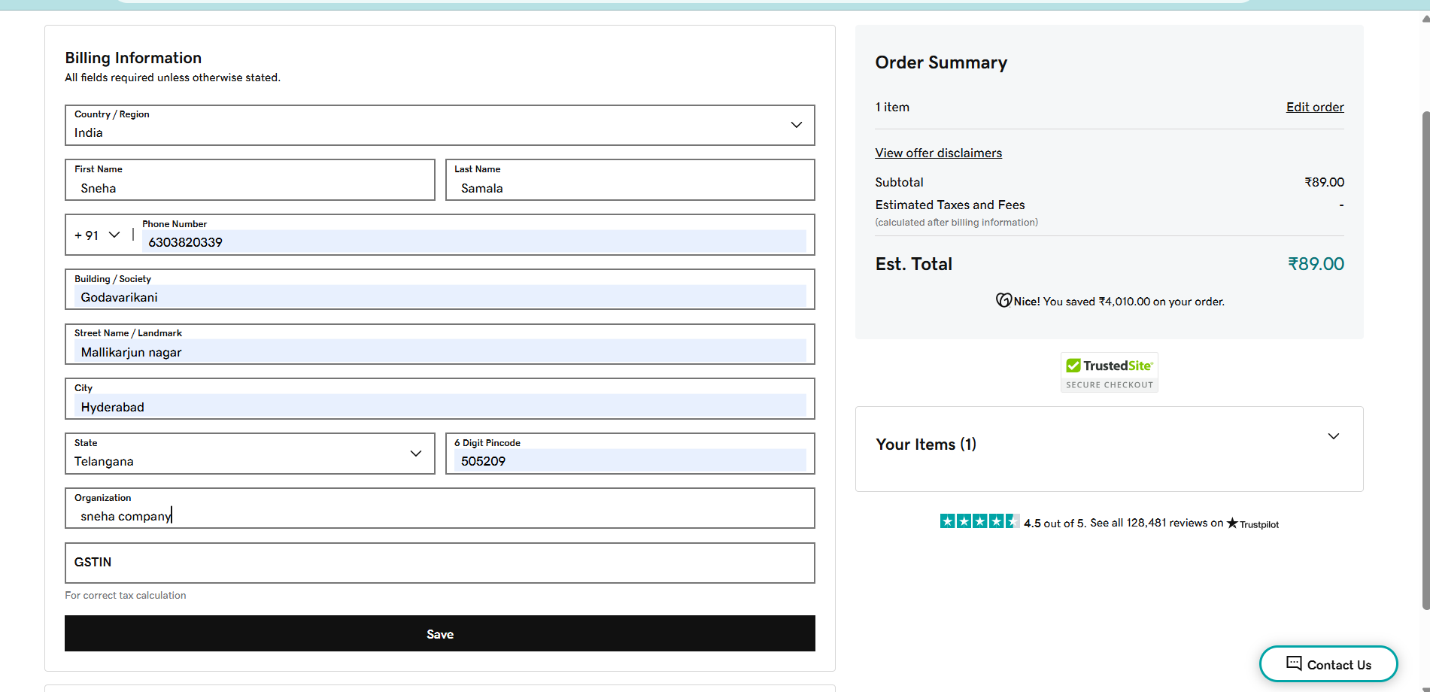

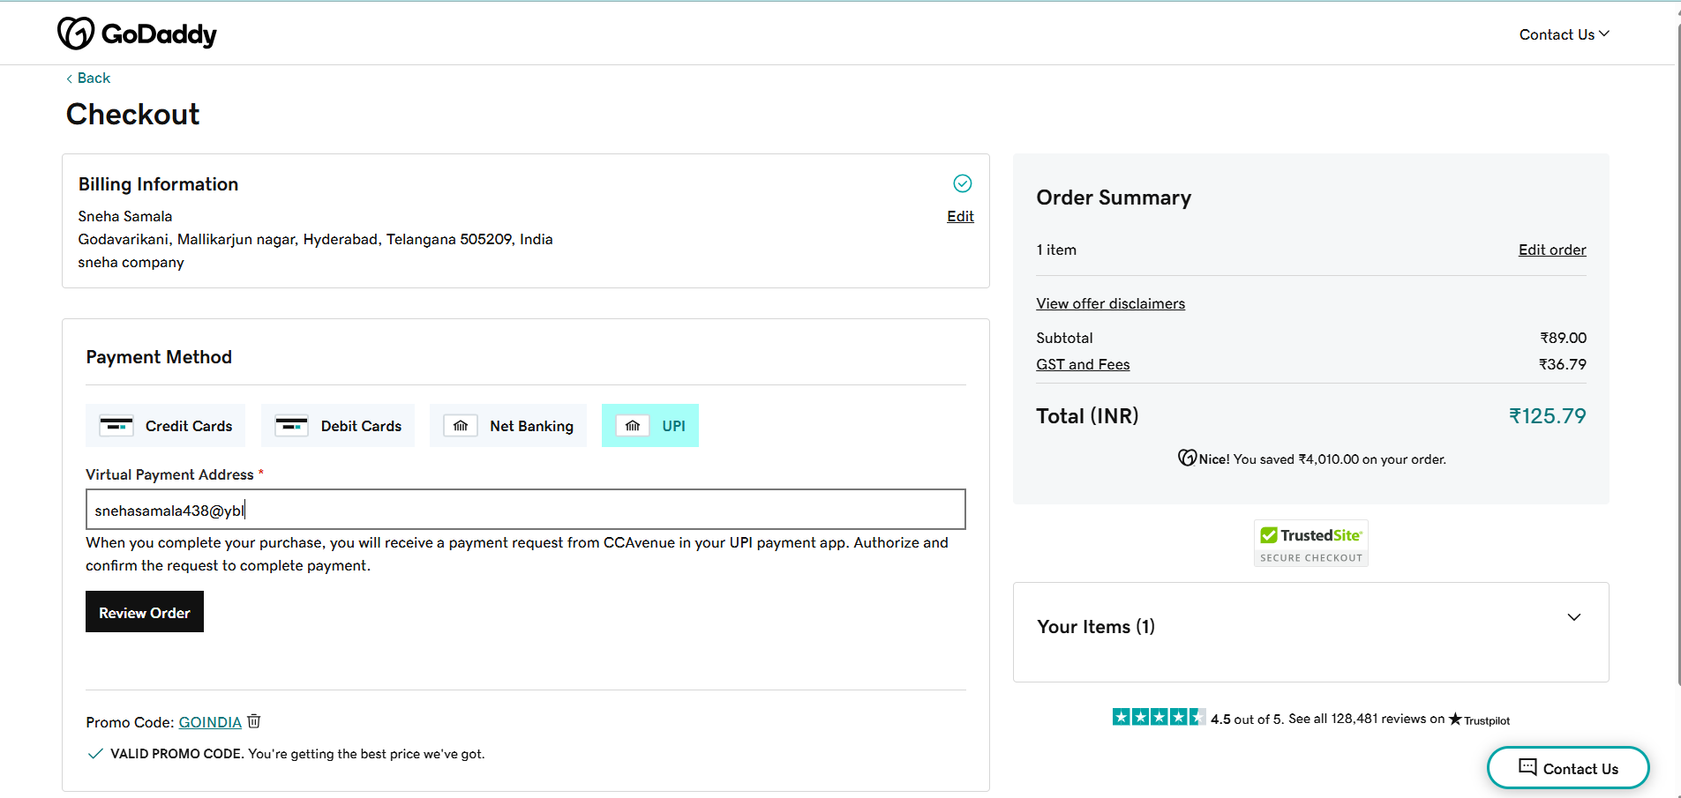

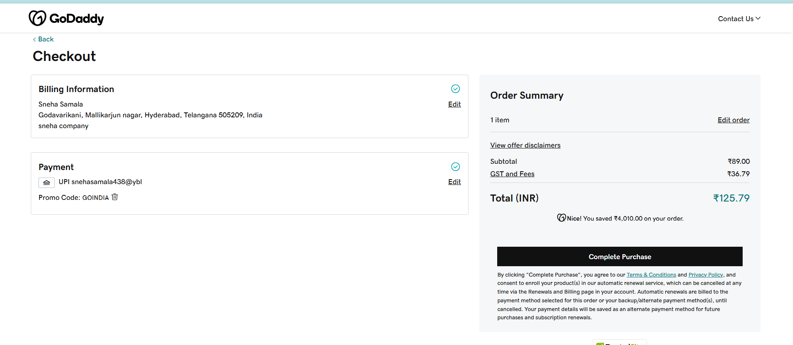

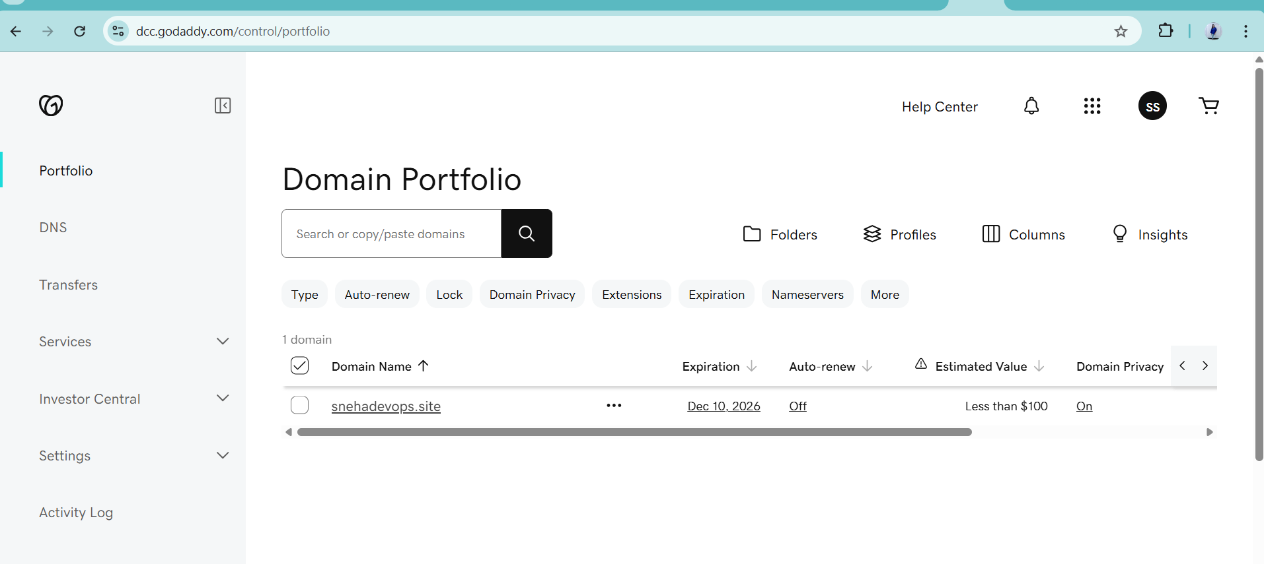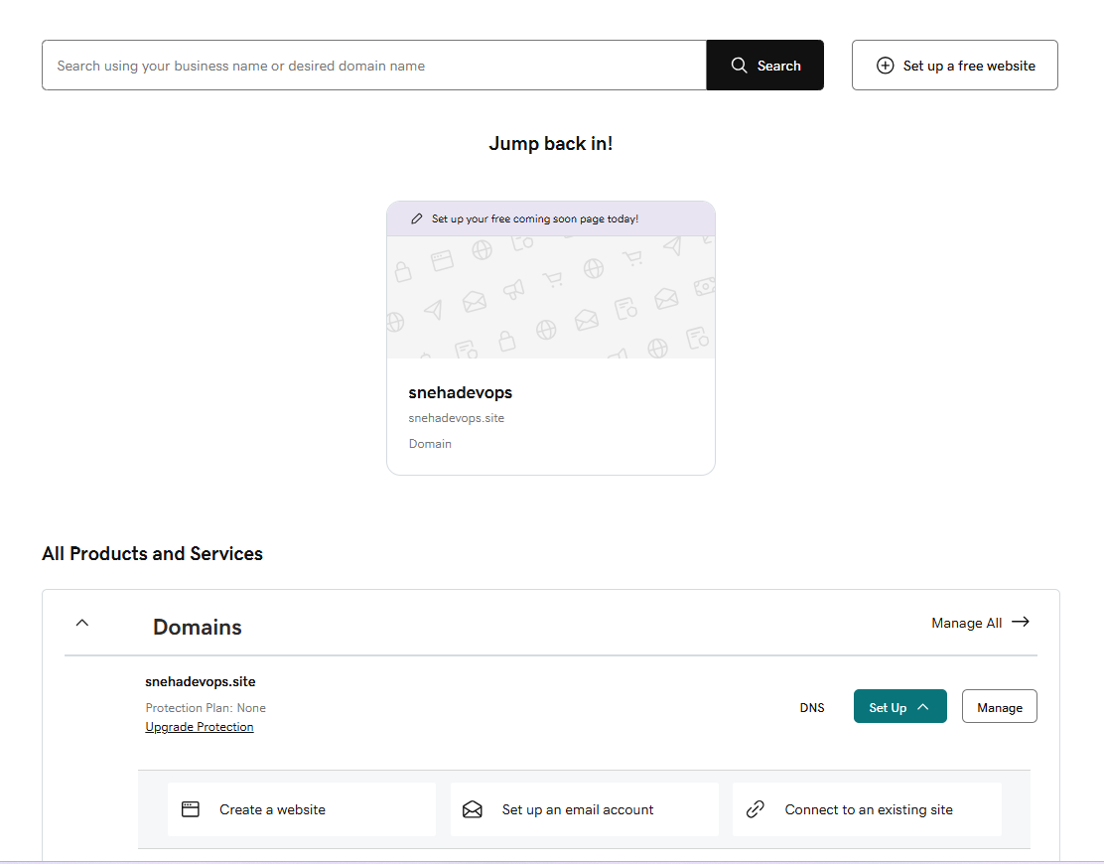

1. Deploy static website in S3.

* i have created the s3 bucket
* and I have taken one static website
* Unzip the static website : index.html
* And uploaded the objects
* Files and folders are uploaded successfully
* Make it public access --> select the file -->actions-->make as public ACL
* Go to the permissions-->bucket public access
* Enable static webhost -->properties-->s3 static website hosting
  + **Enable**
  + **Hosting type: Bucket hosting**
  + **Index document: index.html**
* Access your website
* Check in the browser

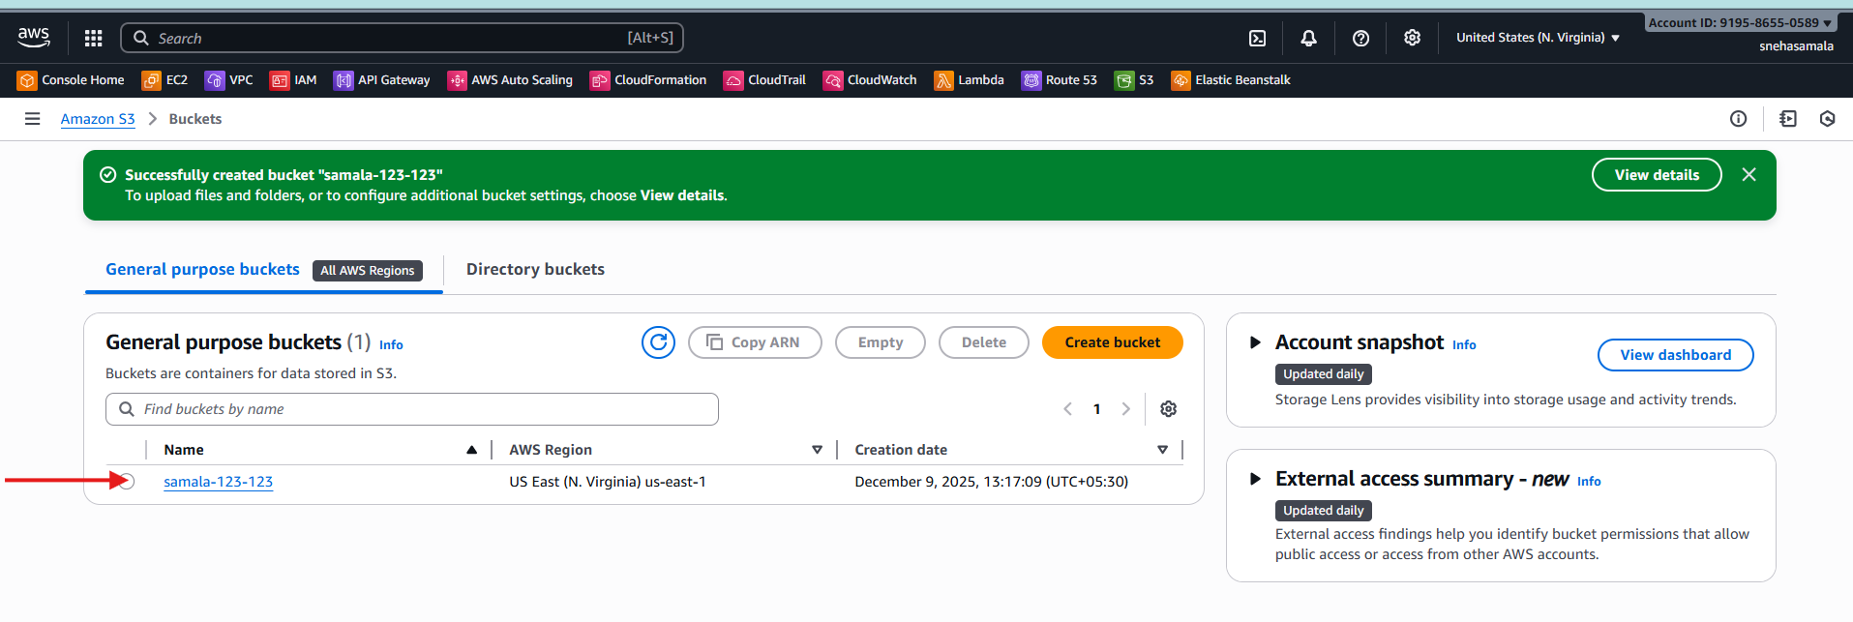

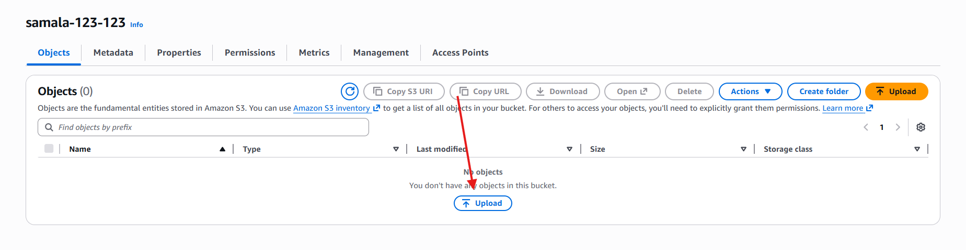

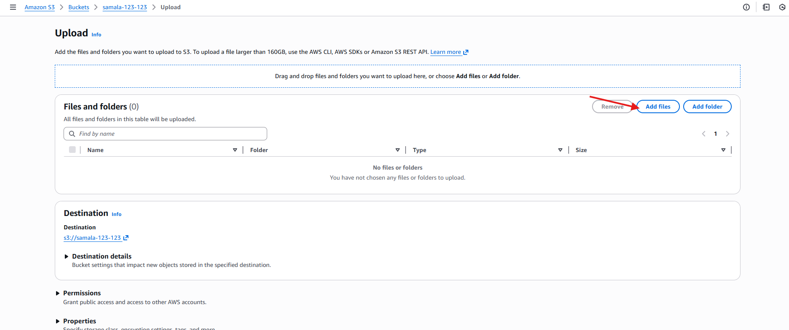

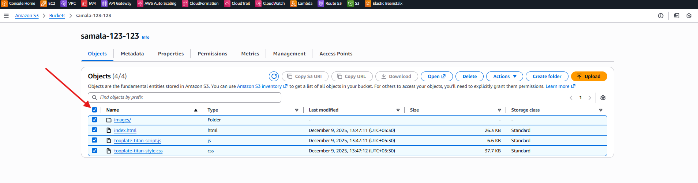

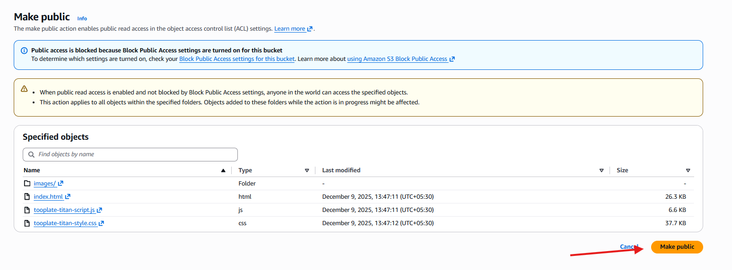

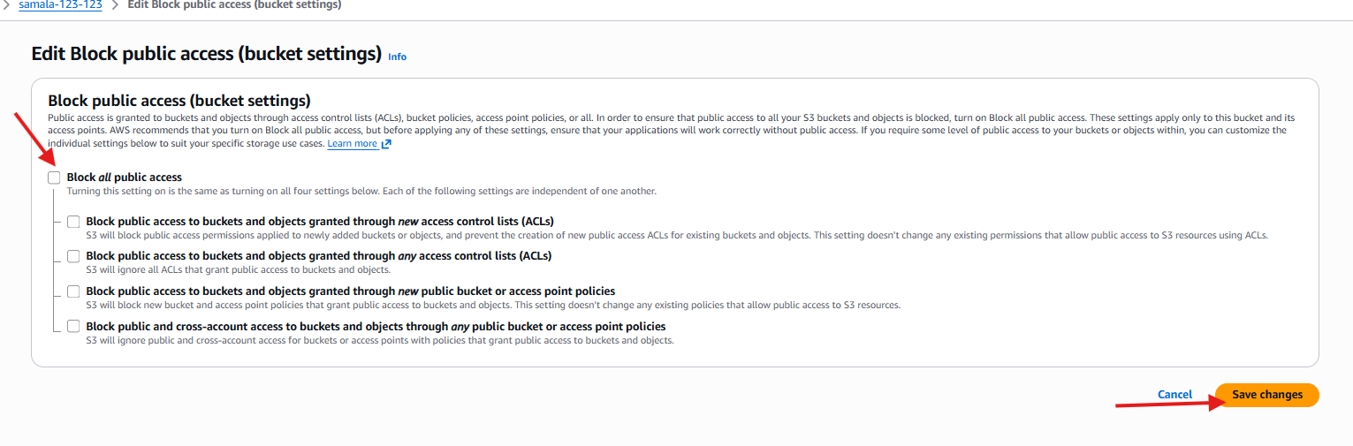

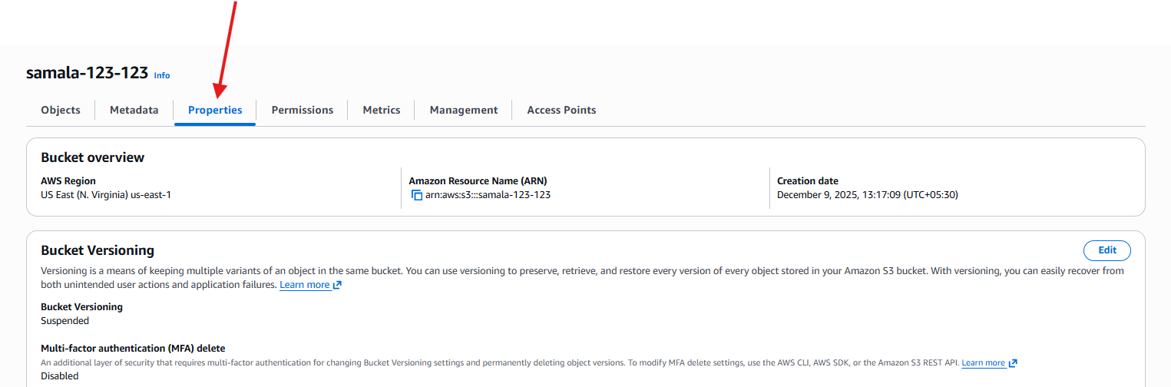

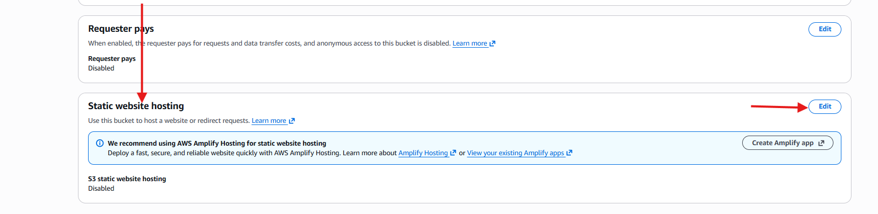

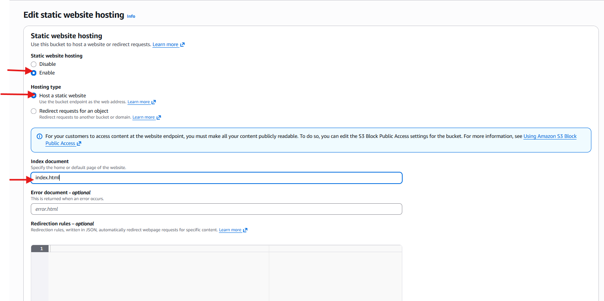

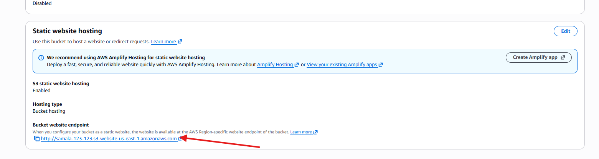

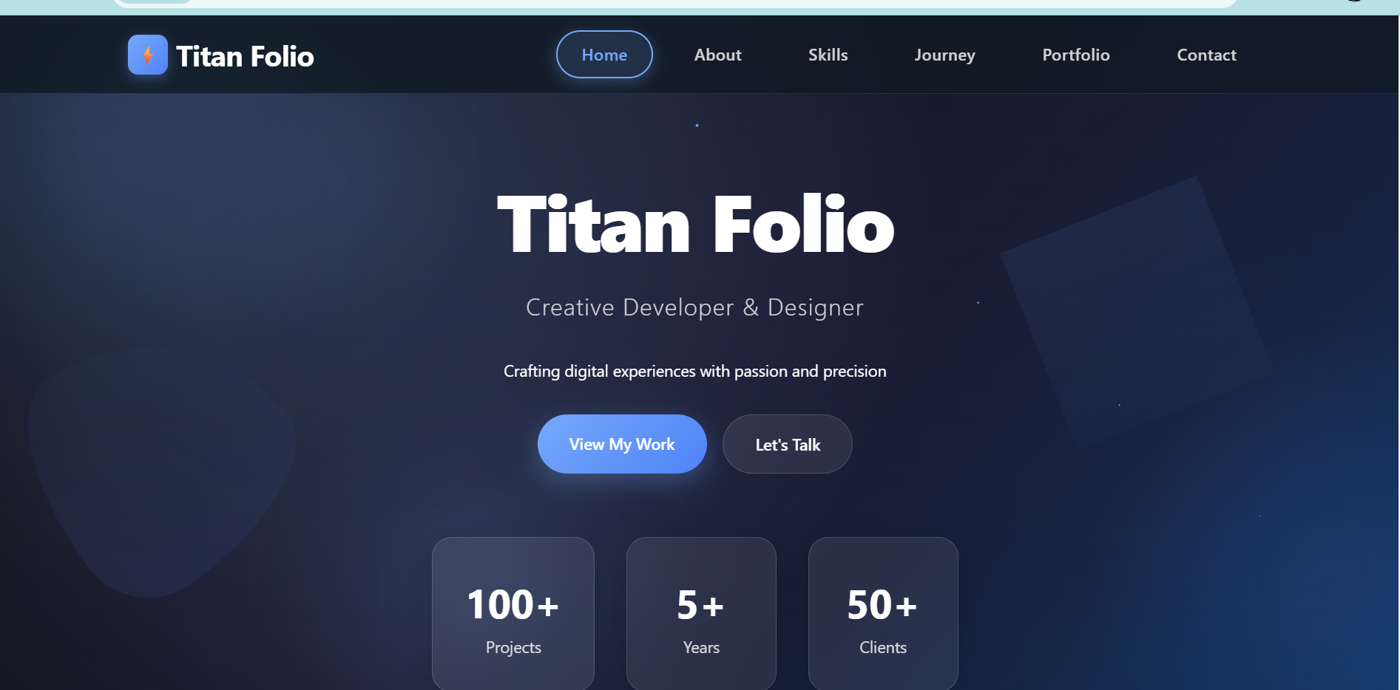

1. Create a CDN and attach one SSL certificate.

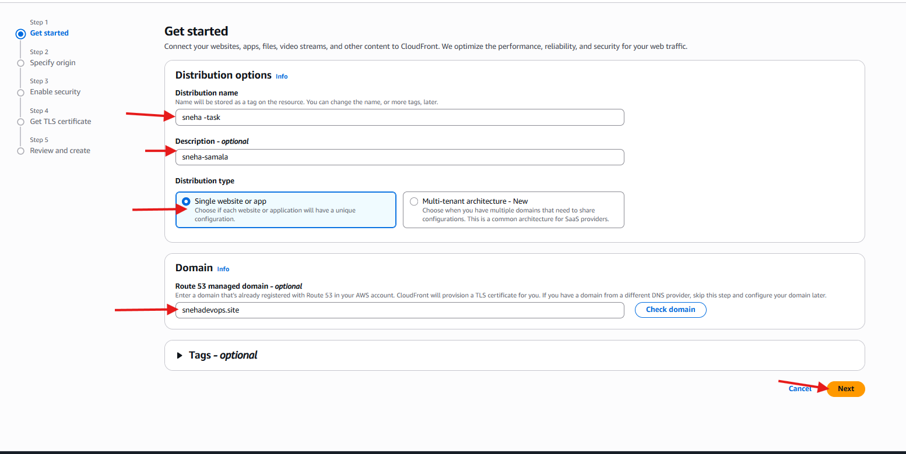

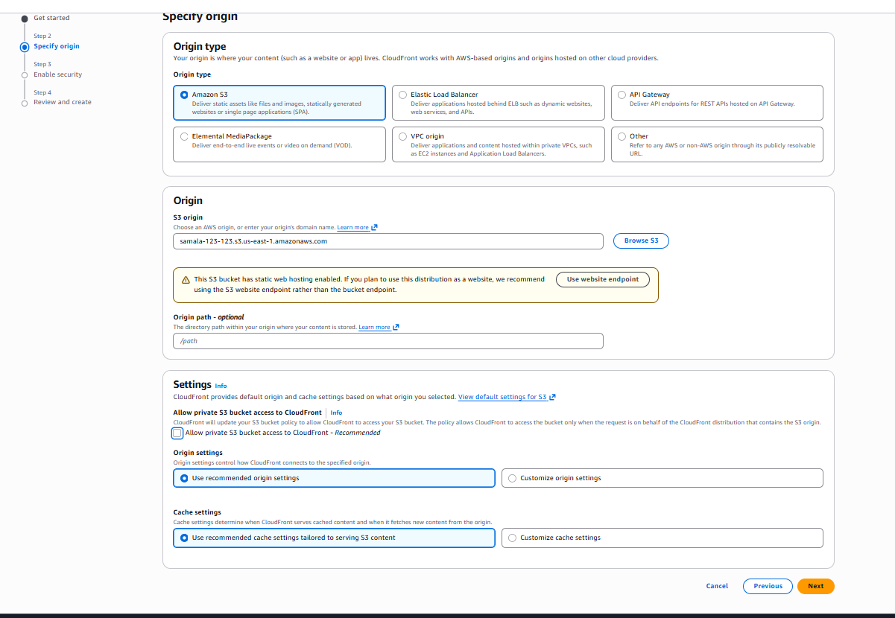

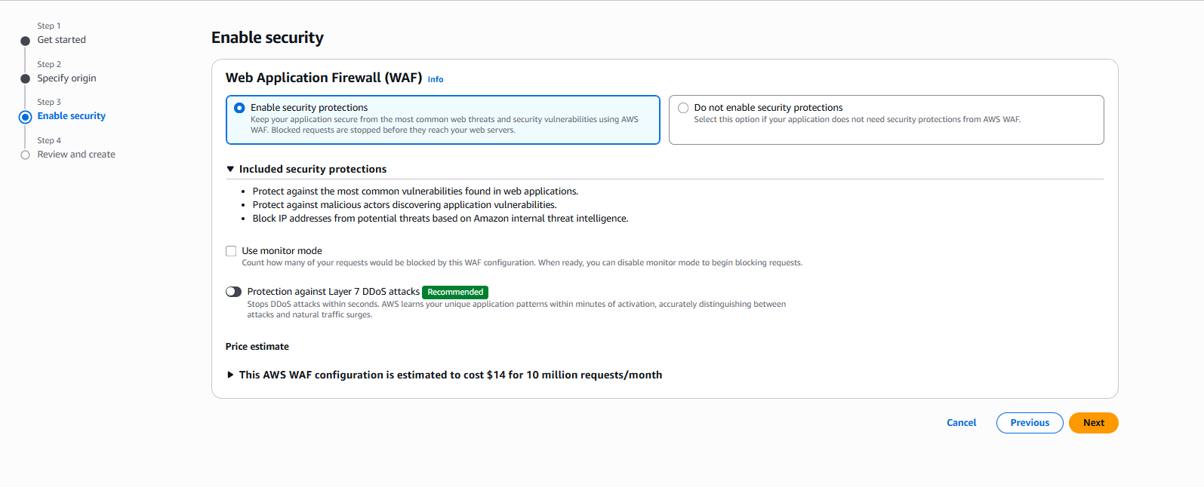

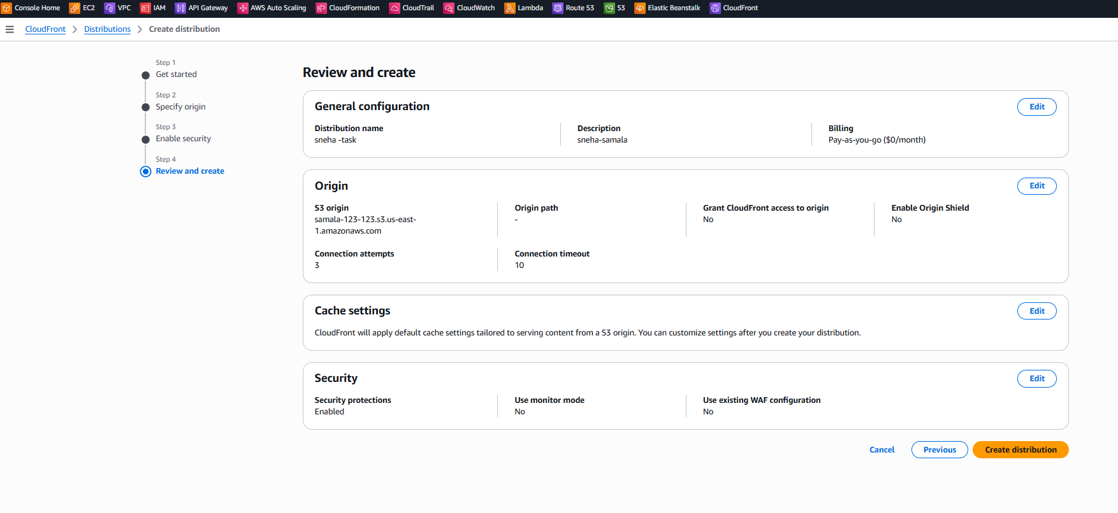

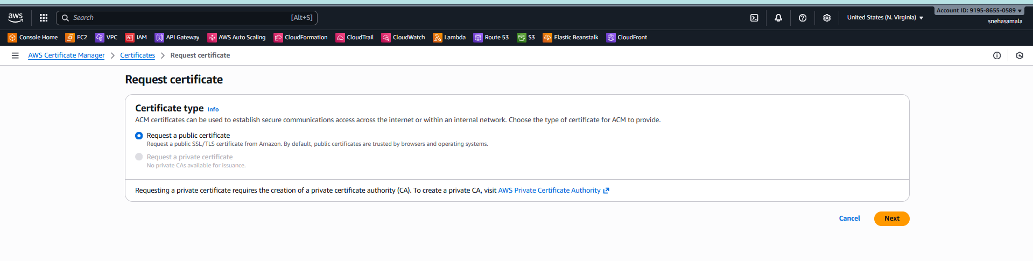

I have created hosted zone certificate is creaed

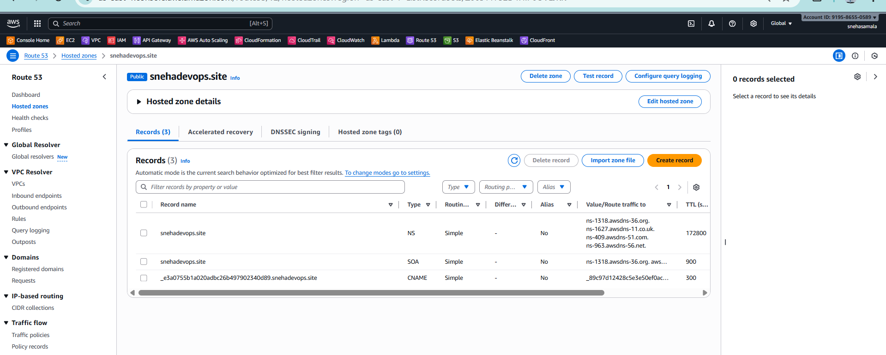

1. Create a Route 53 hosted zone and map the domain with the CDN.

Request SSL certificate in ACM (must be in **us-east-1**)

· Open **AWS Console → Certificate Manager** and change region to **us-east-1 (N. Virginia)**.

· · Click **Request certificate → Request a public certificate**.

* Enable domain name : snehadevops.site
* Choose **DNS validation** and click **Request**.
* ACM will display one or more **CNAME** records for DNS validation — copy them now (you will add them to Route 53 later).

### Create Route 53 public hosted zon

Open **AWS Console → Route 53 → Hosted zone**

Click **Create hosted zone**.

Domain name: snehadevops.site

Type: **Public Hosted Zone**

Click **Create hosted zone**

### Update your domain registrar to use Route 53 name server

Log in to your domain registrar (e.g., GoDaddy)

Edit the domain’s nameservers and **replace** existing nameservers with the **4 NS values** from Route 53

|  |
| --- |
| ns-1971.awsdns-54.co.uk |
| ns-634.awsdns-15.net |
| ns-1169.awsdns-18.org |
| ns-213.awsdns-26.com |

### Add ACM DNS validation records to Route 53

In **Route 53 → Hosted zones → snehadevops.site**, click **Create record.**

Create a **CNAME** record using the Name and Value provided by ACM for validation

Save. ACM will automatically validate and change status to **Issued** (usually within minutes).

Go to the cloud front -->click on the distribution-->alternation domain-->cloud front-->rout-53

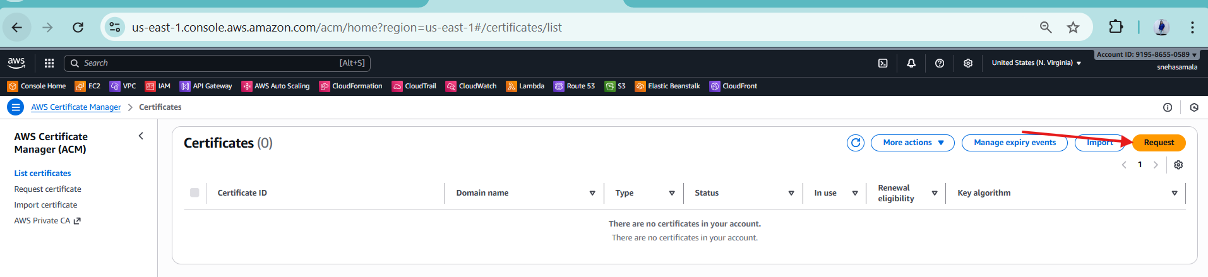

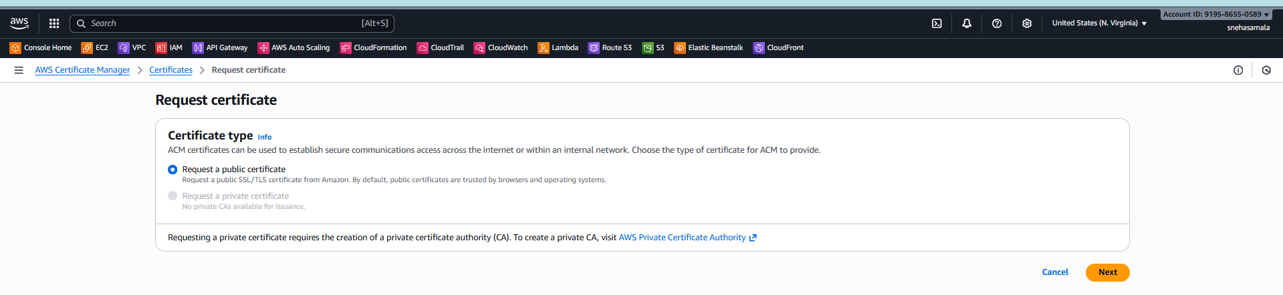

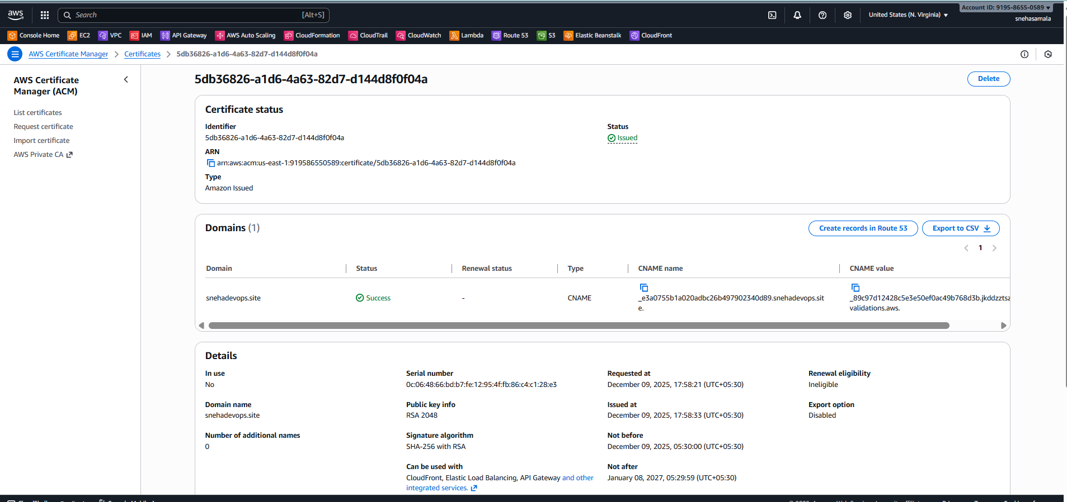

Created rout 53-->create hpsted zone

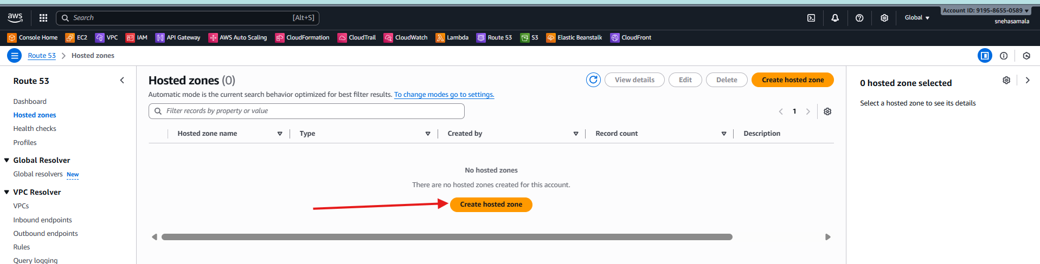

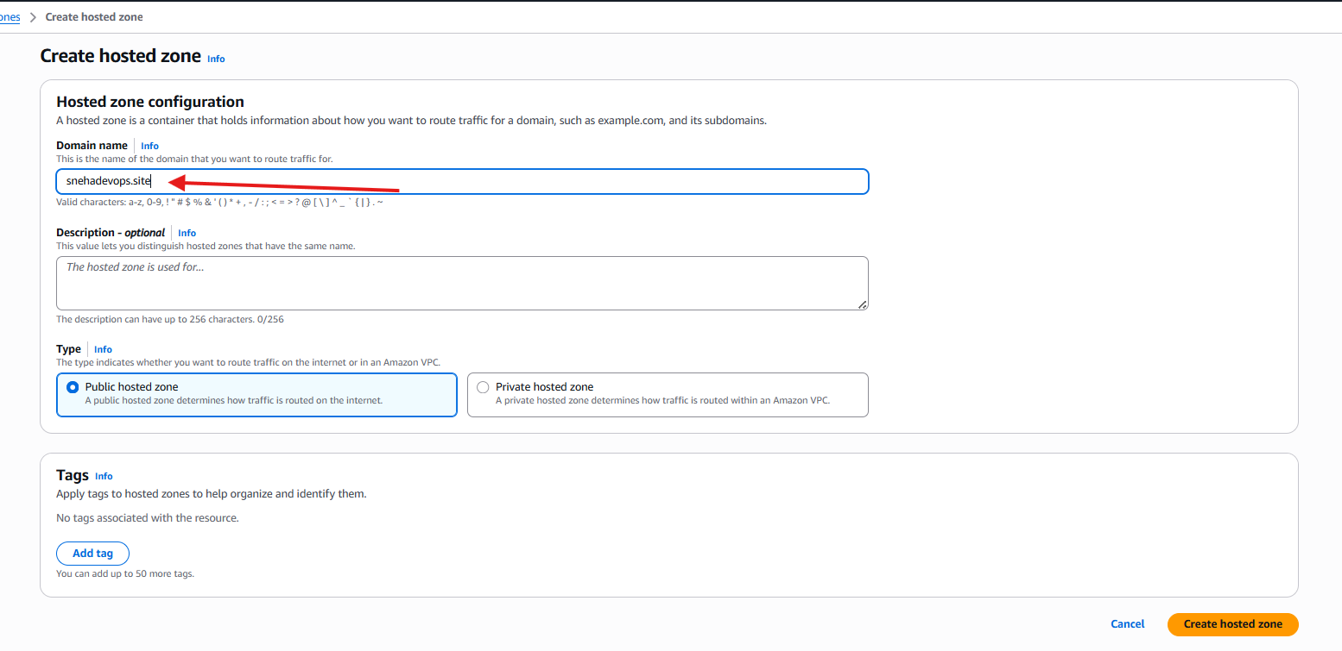

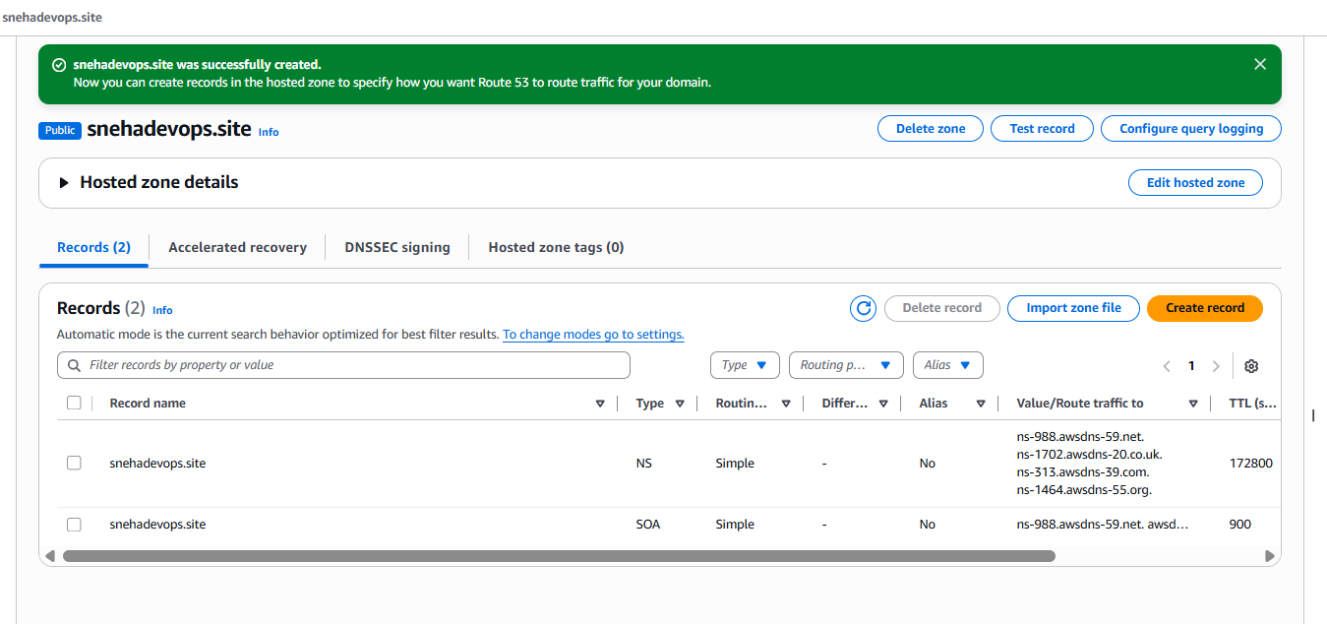

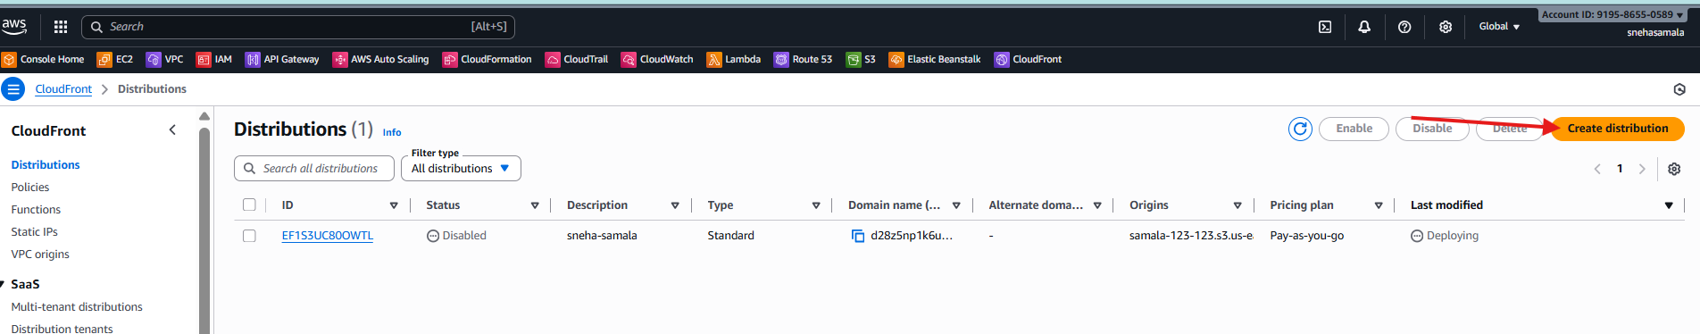

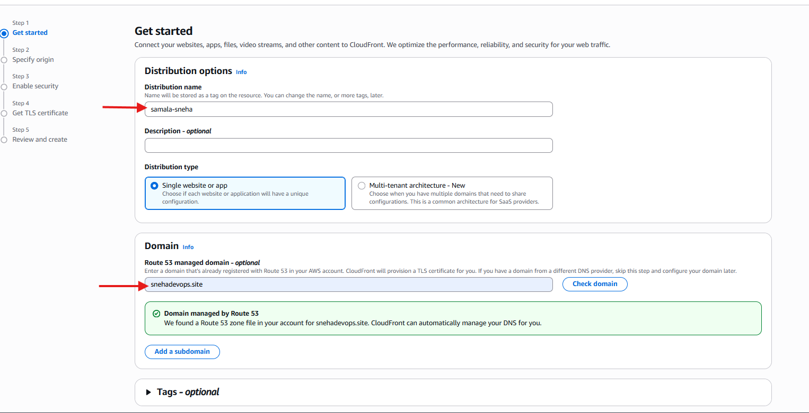

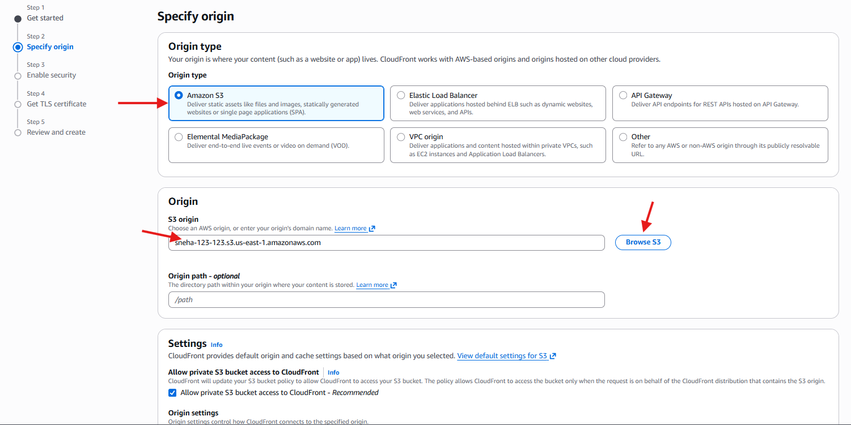

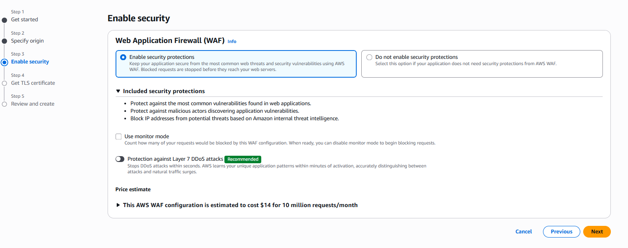

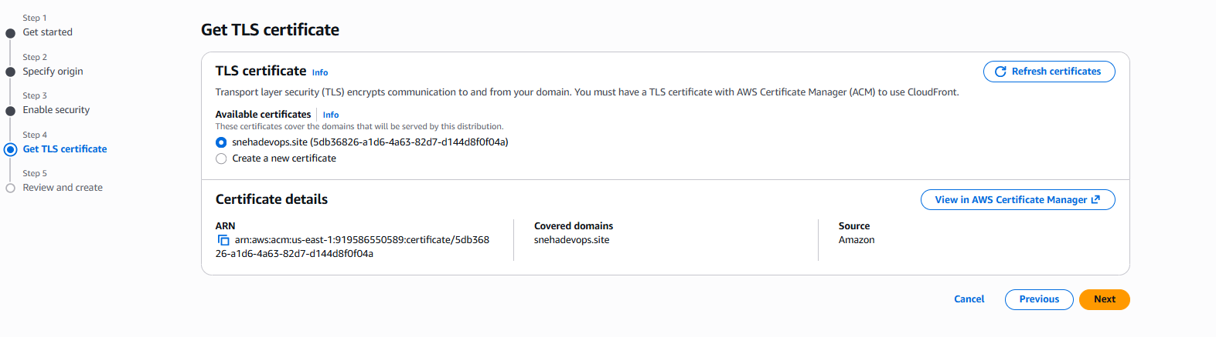

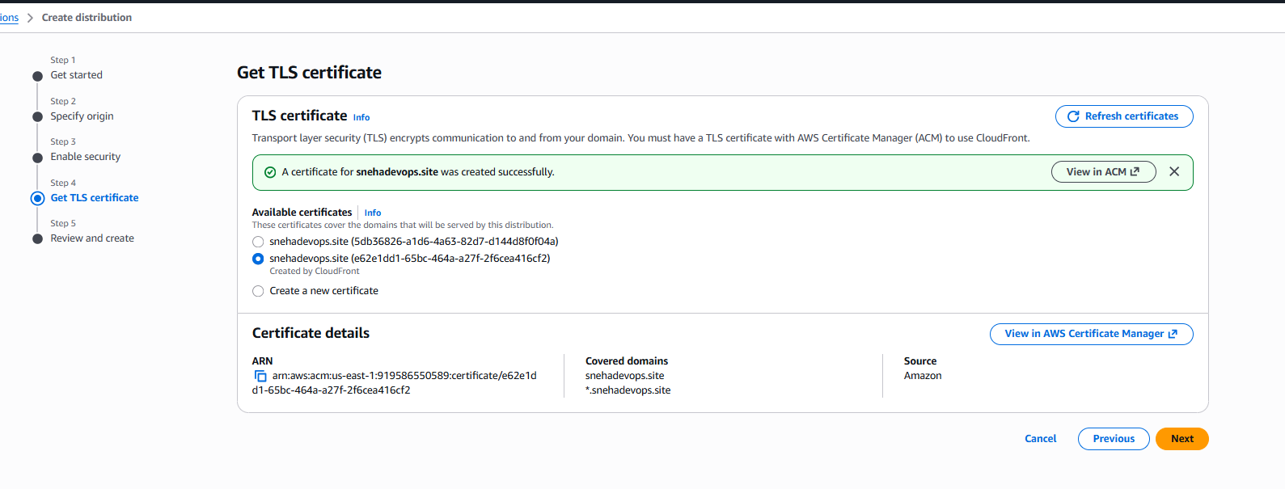

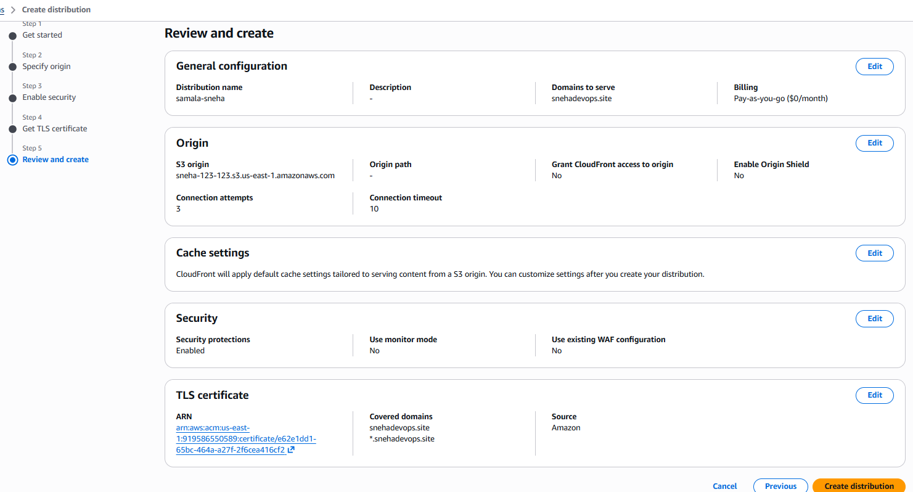

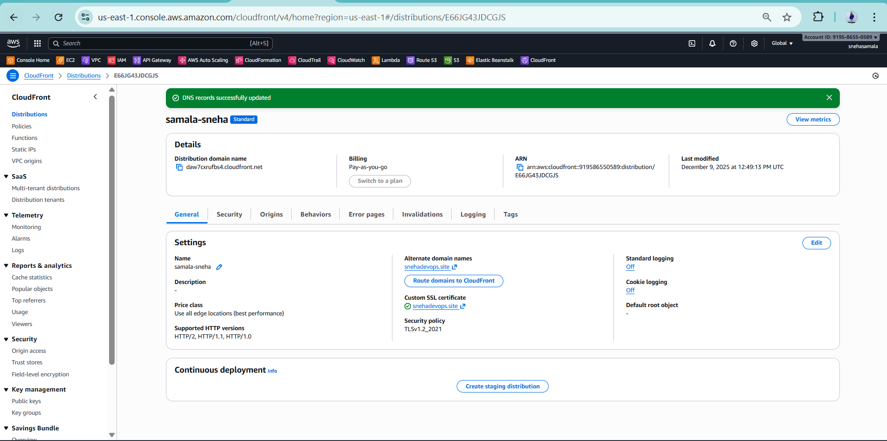

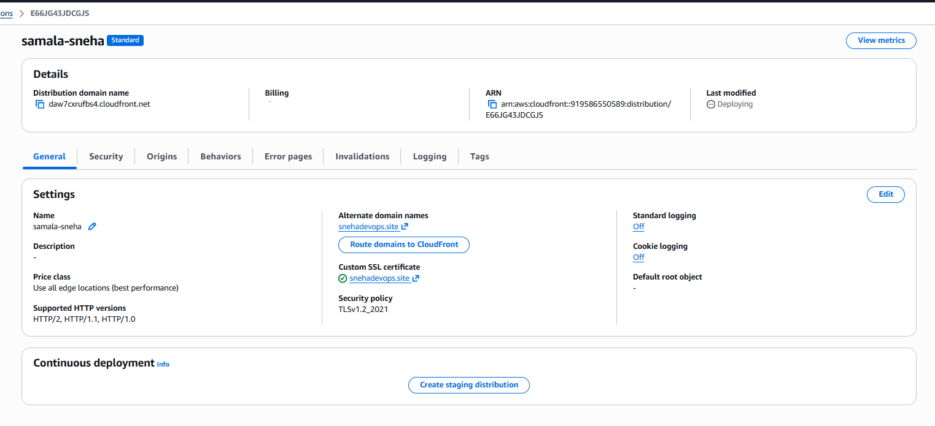

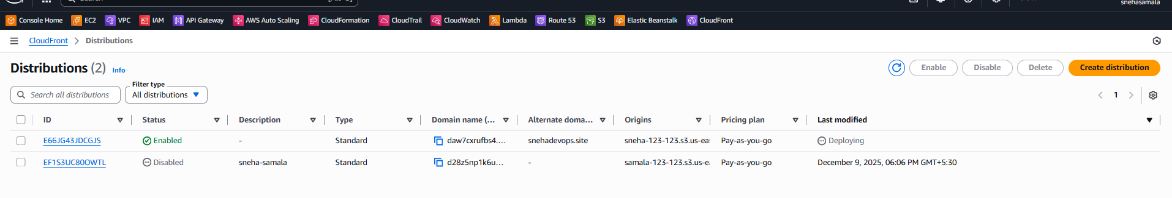

Create the ROUT-53

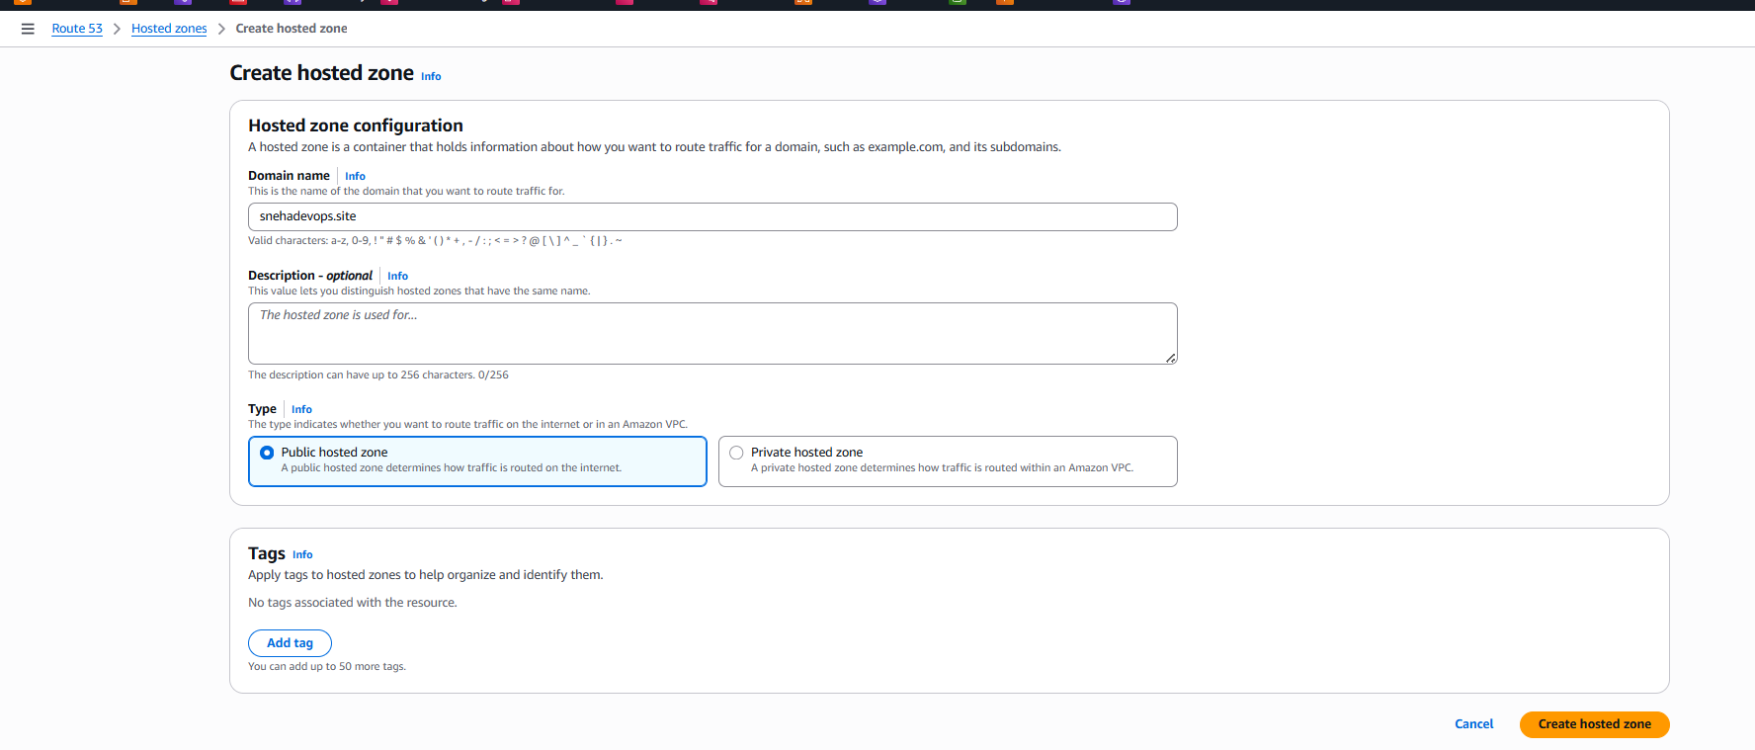

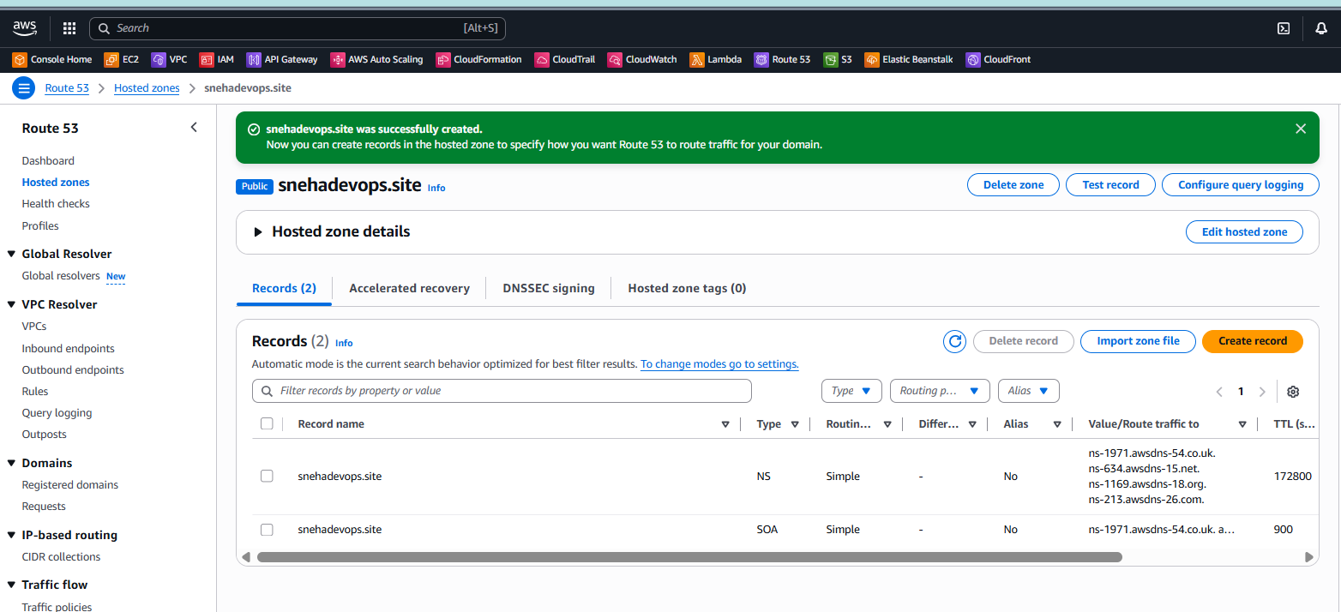

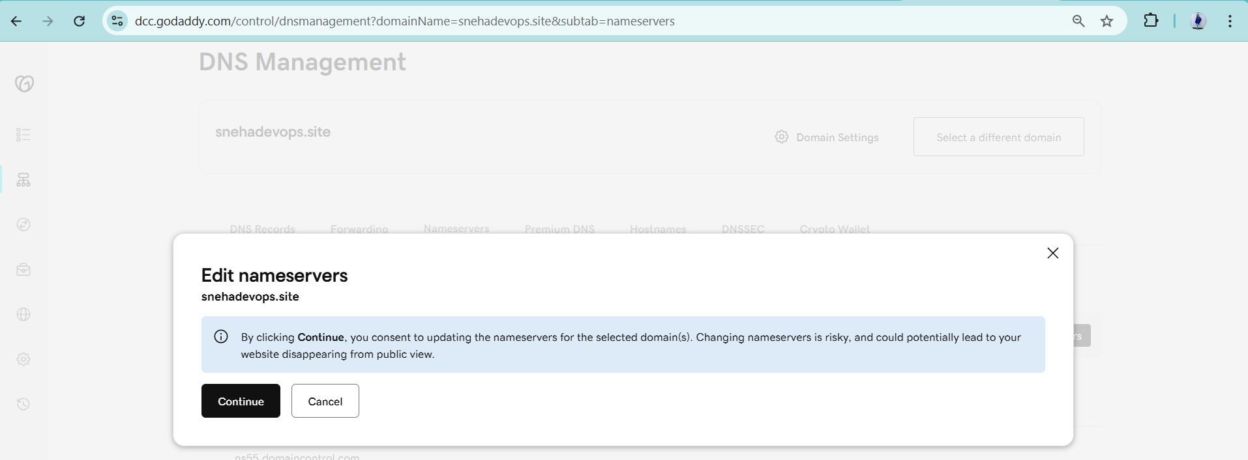

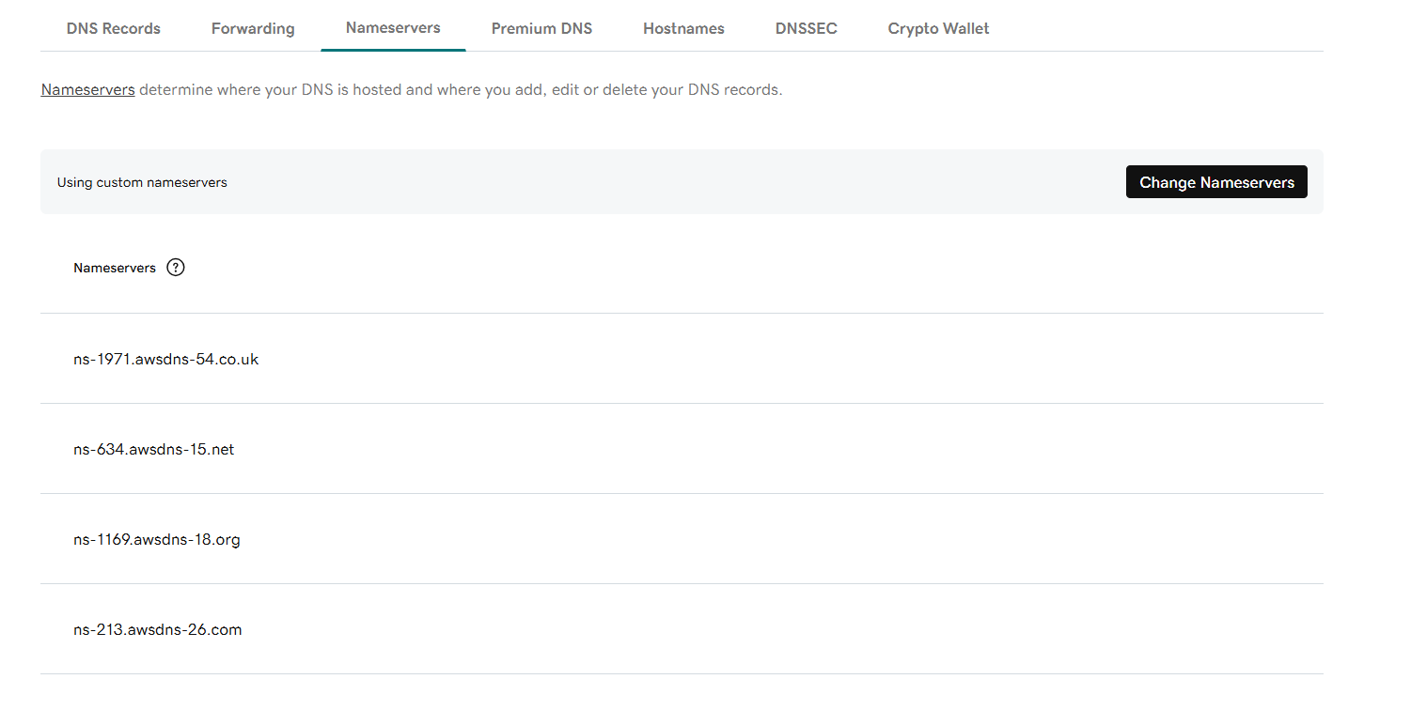



1. Update the index.html in the S3 bucket and ensure the updated file is accessible using the domain name.

Create s3-bucket -->sneha-123-123-->bucket access policy-->public

Go to CLI-->create the file-->index.html and -->error.html

Give permissions 755

Enter the all objects and make public access

Enable ACL’S

Go to properties--> staticwebsite-hostinglink-->http://sneha-123-123.s3-website-us-east-1.amazonaws.com

Access all permissions

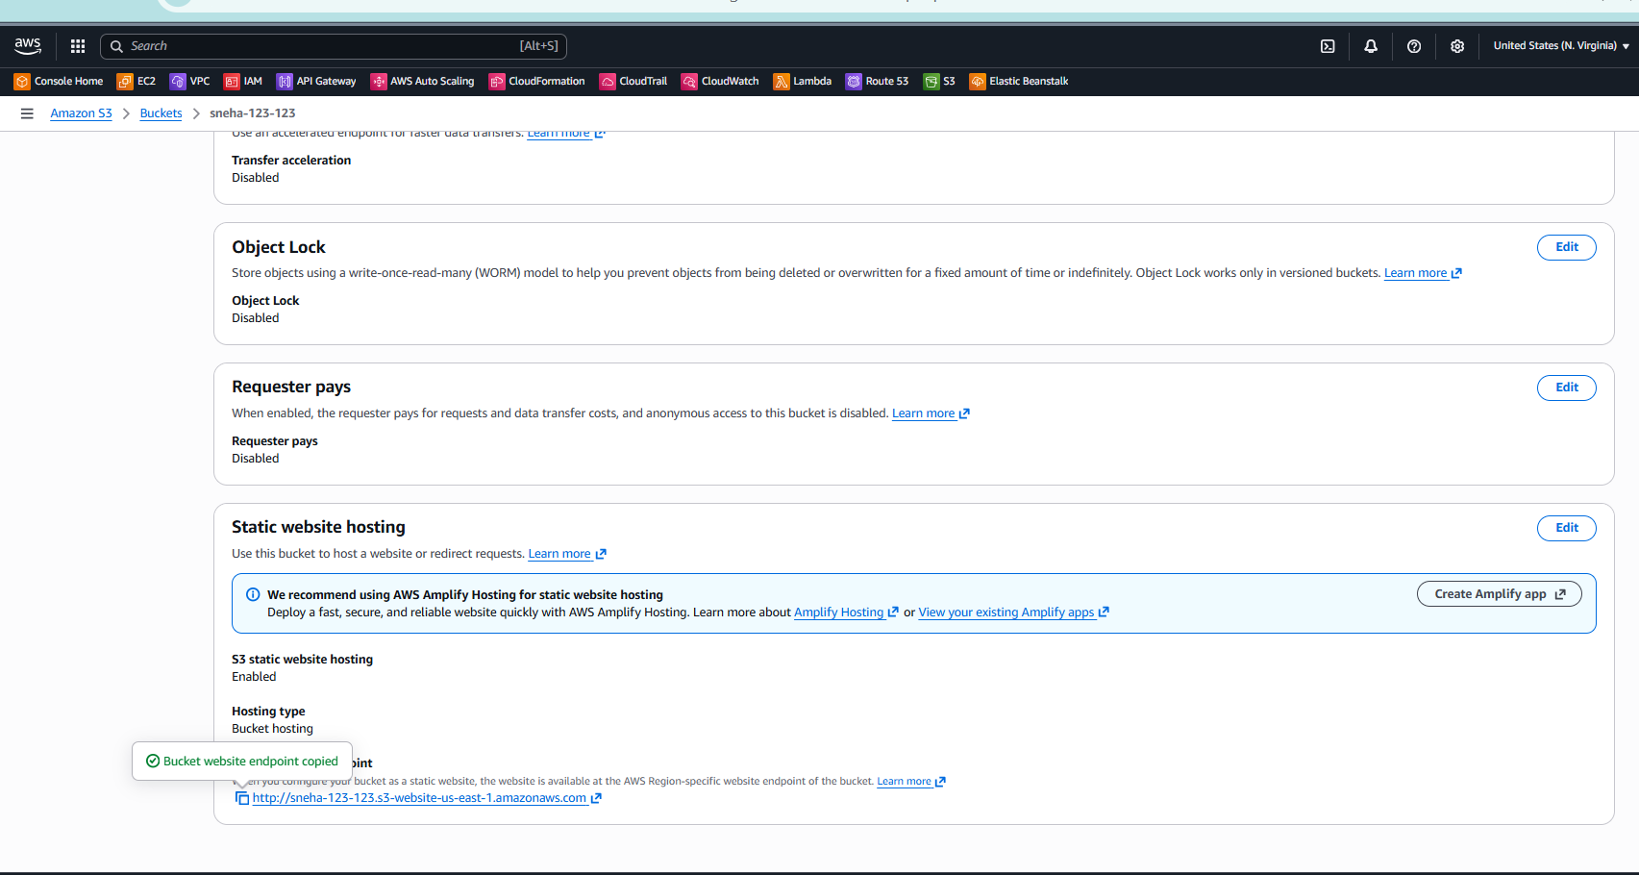

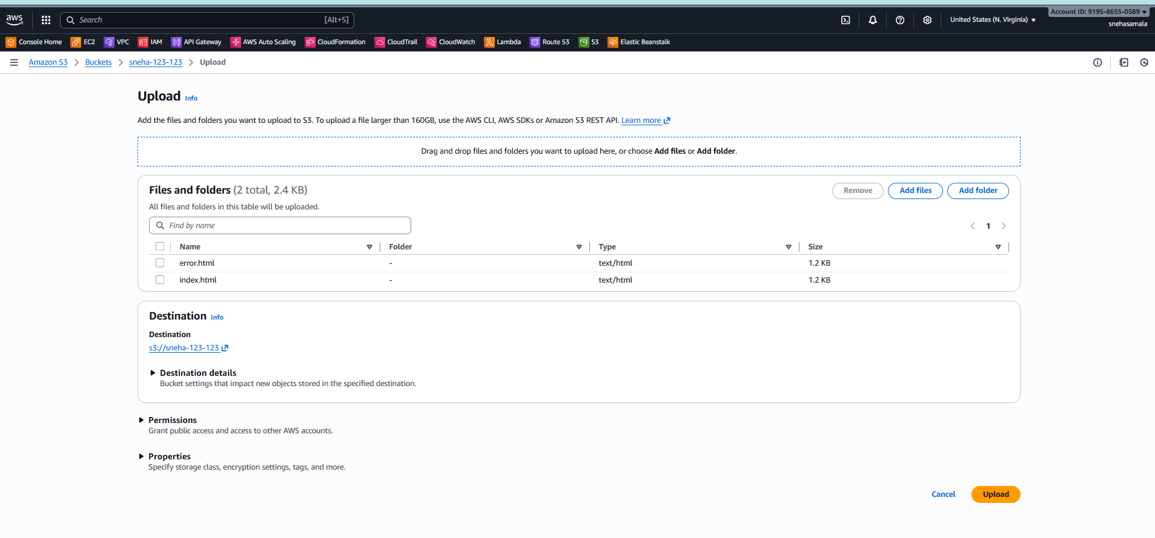

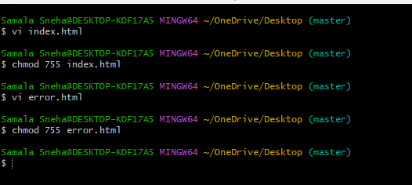

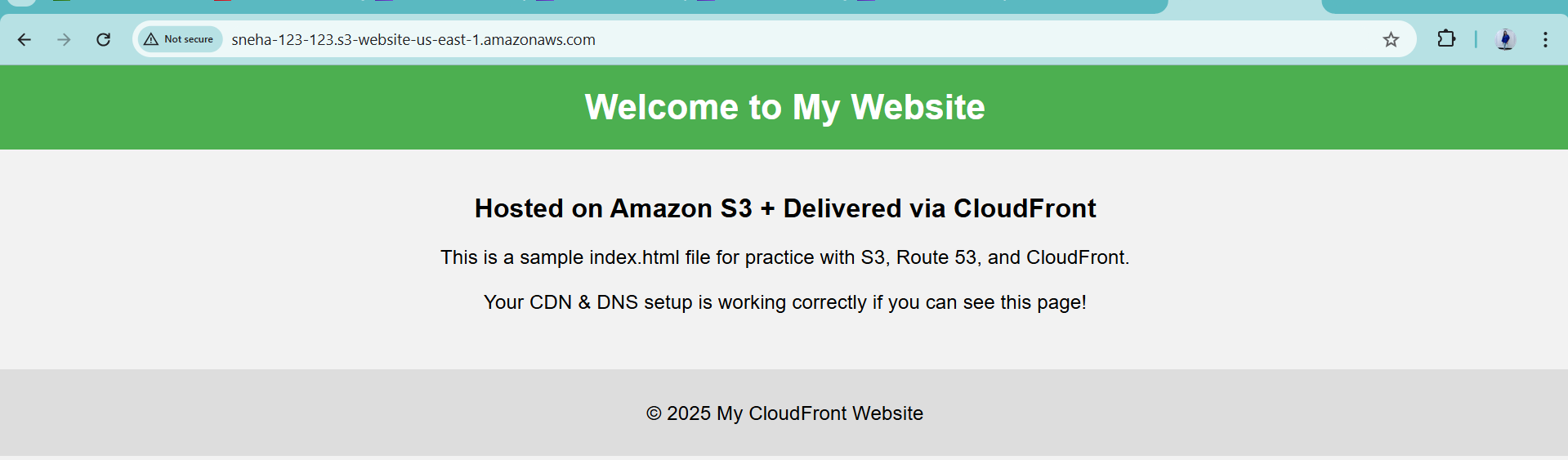

Snehadevops.site

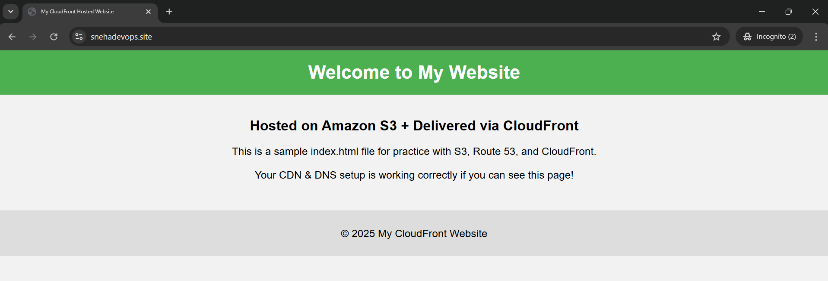

1. Share the domain name in Slack to test the connectivity.

<http://sneha-123-123.s3-website-us-east-1.amazonaws.com>